Non-applicator tampon

What is it?
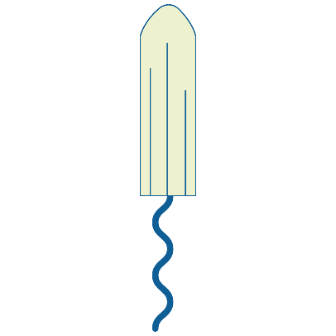
Tampons are small tubes of cotton that are inserted into the vagina to absorb blood before it leaves the body.
Non-applicator tampons are inserted using your fingers to push the tampon inside the vagina, and removed by
pulling a string that is attached at one end.
If the tampon is inserted correctly, you shouldn’t be able to feel it. However if it isn’t put in correctly then it
could be uncomfortable or painful.
Tampons should be changed every 4-6 hours, depending on your flow, and come in a range of absorbencies.
It’s important to not leave a tampon in for too long, or it can cause infection or serious illness (Toxic Shock Syndrome).
After use, tampons should be thrown in the bin and not flushed down the toilet. These are not reusable.

Write your pitch!

Applicator tampon

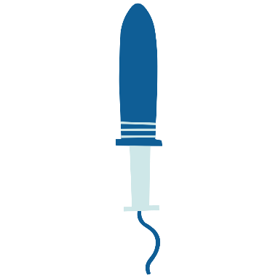
What is it?
Tampons are small tubes of cotton that are inserted into the vagina to absorb blood before it leaves the body.
Applicator tampons are inserted using a cardboard or plastic applicator to push the tampon inside the vagina,
and removed by pulling a string that is attached at one end.
If the tampon is inserted correctly, you shouldn’t be able to feel it. However if it isn’t put in correctly then it
could be uncomfortable or painful.
Tampons should be changed every 4-6 hours, depending on your flow, and come in a range of absorbencies.
It’s important to not leave a tampon in for too long, or it can cause infection or serious illness (Toxic Shock Syndrome).
After use, tampons should be thrown in the bin and not flushed down the toilet. These are not reusable.

Write your pitch!

Disposable pad

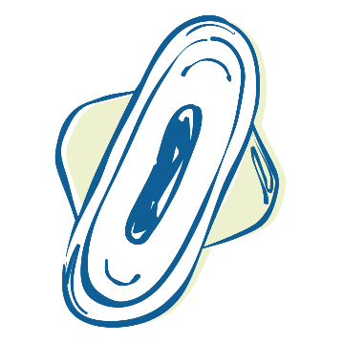
What is it?
Disposable pads are strips of material that soak up blood once it leaves the vagina.
They are attached to underwear via a sticky underside and some have ‘wings’ that fold underneath to help
stay in place and avoid leaks.
They are often the first period product a person will use when they first start their period due to how easy they are to use.
Disposable pads should be changed every 4-6 hours, depending on your flow, and come in a range of absorbencies.
After use, disposable pads should be thrown in the bin and not flushed down the toilet. These are not reusable.

Write your pitch!

Reusable pad

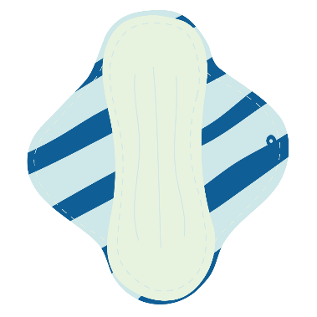
What is it?
Reusable pads are strips of material like cotton, bamboo or hemp that soak up blood once it leaves the vagina.
They are usually attached to underwear via popper buttons attached to the ‘wings’ that fold underneath to help
stay in place and avoid leaks.
Reusable pads should be changed every 4-6 hours, depending on your flow, and come in a range of absorbencies.
After use, reusable pads can be placed in a wet bag when out and about and then washed ready to be reused.
Reusable pads are more environmentally friendly than disposable products and can be more cost efficient with multiple use.

Write your pitch!

Period underwear

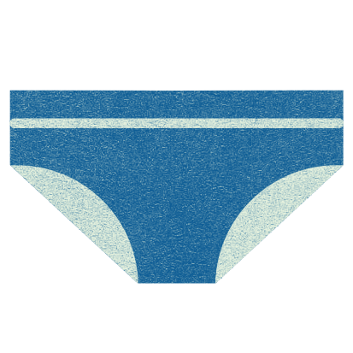
What is it?
Period underwear is underwear made of absorbent materials that can be worn like normal underwear without
the need to use other period products.
Period underwear lasts longer than pads or tampons, and should be changed every 8-12 hours, depending on your flow.
They come in a range of absorbencies and styles including bikini briefs, boxers, high waisted and more.
After use, period underwear can be placed in a wet bag if out and about and then washed ready to be reused.
Period underwear is more environmentally friendly than disposable products and can be more cost efficient with multiple use.
It is also possible to get period swimwear meaning you can go swimming on your period without having to insert anything.

Write your pitch!

Menstrual cup

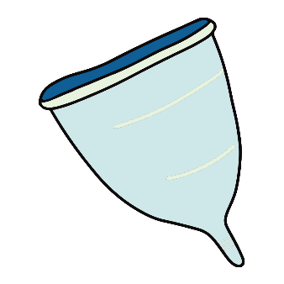
What is it?
Menstrual cups, or period cups, are small containers made from medical grade silicone that are inserted into the vagina
using the fingers to collect the blood before it leaves the body, rather than absorbing it.
If the cup is inserted correctly, you shouldn’t be able to feel it. However, if it isn’t put in correctly then it could
be uncomfortable or painful.
Menstrual cups lasts longer than pads or tampons, and should be emptied every 8-12 hours, depending on your flow.
It’s important to not leave a menstrual cup in for too long, or it can cause infection or serious illness (Toxic Shock Syndrome).
Menstrual cups are more environmentally friendly than disposable products as they are washed and reused and can last
for up to 10 years.

Write your pitch!

