Name: |  | Date isolation commenced:
DOB: |  | Date isolation discontinued:
Room number:
Date of C.diff result:
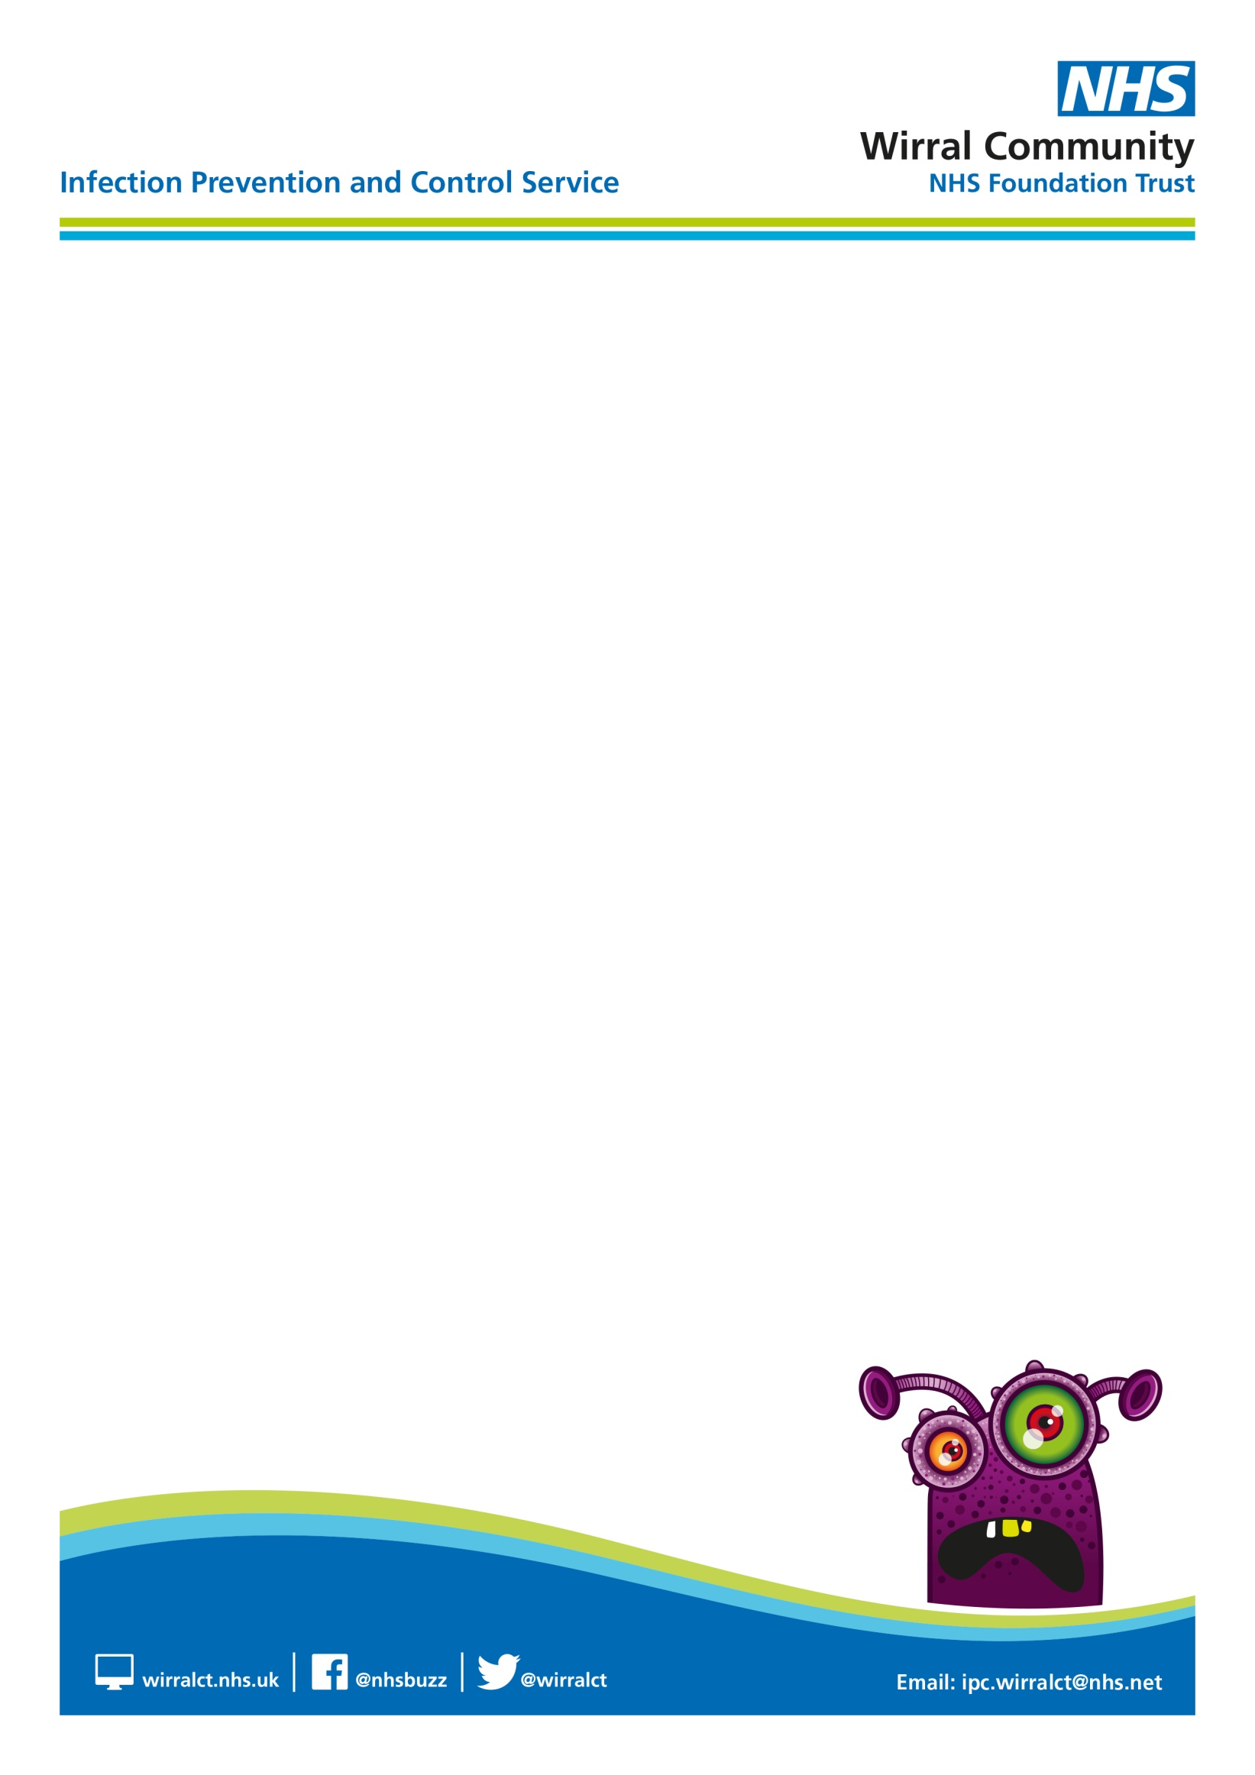

Section 1 Care plan to be used at least daily with people who are suspected of or are known to have current diagnosis of Clostridioides difficile (C.diff). This should be used in association with your C.diff guidelines and followed until the person is symptom free for 48 hours and has passed a formed stool, or a normal stool for them. Retesting to look for clearance is not advised as C.diff may persist in the bowel without causing disease and there can be prolonged shredding.

Care plan – Section 1  Completed on initial assessment and daily until the person is symptom free for 48 hours and has passed a formed stool or a normal stool for them. | Date (daily)
 | √ tick and initial boxes below
Person or carer informed of C.diff result, if appropriate to do so, and provided with a C.diff information leaflet which has been discussed with them (if appropriate)
Explain to the person, family and visitors the importance of hand hygiene with soap and water and advise to avoid the use of alcohol gel

Is the person aware of the requirement to isolate whilst continuing to have symptoms of diarrhoea
Healthcare professional informed of result and current medications reviewed
C.diff treatment prescribed and administered following GP review
To prevent dehydration, fluid intake encouraged (Unless on fluid restriction for medical reasons and recorded within persons records.

Monitor persons nutritional intake and raise any concerns with a healthcare professional for consideration of dietician review.
Monitor persons bowels on Bristol Stool Chart (BSC)
Person able to be isolated

. . . . continued overleaf

Section 2 Practice and environmental standards to be used on suspicion or confirmation of C.diff result and then at least weekly whilst the person(s) remain symptomatic.
Section 2a Practices and environmental standards  IPC would recommend this is completed daily until the person is symptom free for 48 hours and has passed a formed stool or a normal stool for them. | Date (daily)
 | √ tick and initial boxes below
Is the person isolated in a single room with en-suite facilities/own commode/designated equipment
Is appropriate signage displayed outside the room to alert staff and visitors of the requirement to take additional precautions
If safe to do so is the door to the persons room closed

Is appropriate PPE available and stored correctly, away from contamination risk, outside the persons room
Is appropriate PPE applied correctly before entering the persons room
Is PPE removed correctly before leaving the persons room and discarded as clinical waste
Hand hygiene must follow removal of PPE

Are staff caring for the person using soap and water only for hand hygiene
Is the person encouraged to clean their hands before meals and after using the toilet/commode
Are enhanced cleans being performed in the persons environment twice daily using a 2-stage cleaning process detergent/disinfectant (e.g. 1,000 ppm of available chlorine), or using a combined product

Is the persons mattress and pillows, clean and in good condition
If a commode is in use for the symptomatic person, is it clean (cleaned and disinfected between use) and in good condition and dedicated to that person?
Single use or dedicated equipment used were possible. If dedicated/ communal equipment used ensure a 2-stage cleaning process (detergent/disinfection) followed
Is the persons laundry treated as infectious linen and placed in a red alginate bag then into a laundry bag?
SECTION 2B - PRACTICES AND ENVIRONMENTAL STANDARDS
IPC would recommend this is completed weekly until the person is symptom free for 48 hours and has passed a formed stool or a normal stool for them.
Are staff bare below the elbow?
Are staff using the Ayliffe technique for hand hygiene in line with the World Health Organization’s 5 moments for hand hygiene moments?
Are hand hygiene audits completed?
Are staff witnessed applying and removing PPE correctly throughout the setting?
Is PPE readily available throughout the setting?
Is the general environment visibly clean and clutter free?
Is the cleaning checklist up to date?
Is the mattress audits up to date?
is clean linen stored correctly?
Is waste disposed of correctly?
Is the sluice/dirty utility room clean and clutter free?
Does the setting have a macerator/washer disinfector?

Is the macerator/washer disinfector in good working order?
If not, is there a safe system in place to appropriately dispose/disinfect receptacles e.g. bed pans/urinals?

Appendix 1
Infection Prevention and Control (IPC) improvement plan

Improvement plan KEY

1 | Improvement agreed but not actioned
2 | Improvement in progress
3 | Improvement fully implemented
4 | Improvement never actioned (please state reasons)
5 | Other (please provide supporting information)

Area for improvement (to be completed by IPCN ) | Improvement Evidence  (to be completed by registered manager) | Date Completed | Action Status
All staff view IPC bitesize C.diff training on IPC digital hub

Appendix 2 Care Home Deep Cleaning Checklist

GUIDANCE FOR DEEP CLEANING – CARE HOMES

What is deep cleaning?
Deep cleaning is not routine environmental cleaning that is undertaken daily within the care environment, but is additional cleaning that should be undertaken in the following situations:

- following outbreaks and would involve cleaning - the whole environment
- post discharge, transfer or death of individual service user – single room and en suite
- when isolation of a resident with a known infection is no longer required – single room and en suite.

Deep cleaning is the thorough cleaning of all surfaces, floors and soft furnishings and reusable equipment either within the whole environment or in an individual’s room. This will include:

- skirting boards, picture and dado rails
- window sills and frames
- all ledges, shelves and flat surfaces
- chairs, including dining chairs
- pressure relieving cushions and aids
- bed frames
- mattresses
- soft furnishings including curtains and blinds
- curtain rails and tracks
- floors and carpets
- light fittings and lamp shades
- reusable equipment including catheter stands, urinals, bed pans
- wheelchairs, zimmer frames, walking aids
- hoists, including all hoist slings and manual handling aids
- sinks, toilets, baths/showers plus taps, flush and door handles, raised toilet seats, light pull and emergency pull toggles
- commodes
- soap and towel dispensers.

What equipment is required for deep cleaning?

Care workers and housekeeping staff that are carrying out deep cleaning should wear disposable plastic aprons and household or disposable gloves. The physical removal of dirt and micro-organisms is achieved by wiping or scrubbing using hot water and neutral detergent. Where a disinfectant is required, an appropriate product this will be advised by the Infection Prevention and Control Service.

Deep cleaning should be undertaken using:

- clean bucket
- clean hot water and general purpose detergent
- colour coded disposable cloths
- floor mop with disposable or washable mop head
- vacuum cleaner fitted with a HEPA filter
- steam cleaner or carpet shampooer.

Deep cleaning procedure:

- wear personal protective clothing (minimum disposable gloves and apron)
- water and detergent solutions, disposable cloths and mop heads used for cleaning should be changed for each episode of cleaning when moving from one environment to another (room to room) and when the water is visibly dirty or contaminated
- remove/dispose of unwanted items (flowers, equipment etc.)
- take down curtains and send to the laundry
- strip the bed. Clean the mattress with detergent solution and disinfect if necessary
- work from the cleanest to the dirtiest areas, starting at the higher levels and working down.

Clean and disinfect , the following:

- high level surfaces and curtain rails
- fittings and furniture using detergent and water
- door handles and horizontal surfaces
- service user equipment
- bath or shower room
- toilet/commodes
- soft furnishings should be shampooed or steam cleaned
- carpets should be vacuumed (vacuum cleaners should be fitted with a HEPA filter) and then steam cleaned (preferred method)
- discard waste and clean waste bin
- clean all cleaning equipment and leave to dry.

Following deep clean, dispose of gloves and apron and wash hands.



Appendix 3 Stool Chart
Name: |  | Unit & Room No:
Date of Birth: |  | Date Isolated:
NHS No: |  | Time Isolated:

STOOL CHART

Type 1  Separate hard lumps | Type 2  Sausage shaped/  lumpy | Type 3  Sausage with cracks | Type 4  Sausage/  Snake like | Type 5  Soft blobs  Easily passed | Type 6  Fluffy pieces  Ragged edges/mushy | Type 7  Entirely liquid
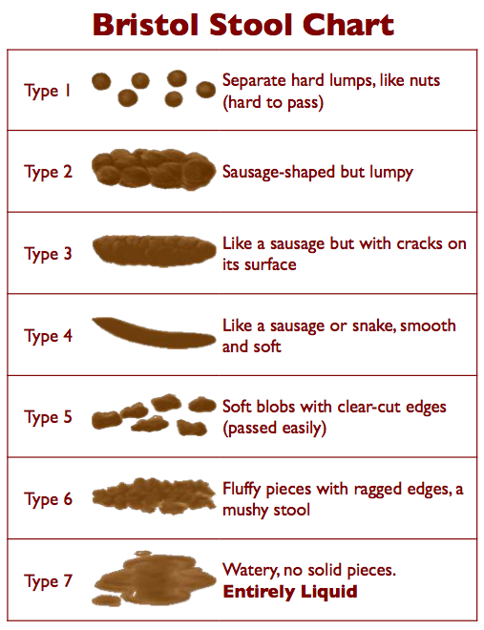

Date | Time | Consistency  Bristol Stool Chart Scale Type 1-7 | Colour | Amount/  Volume | Date Sample Sent (if applicable) | Signature & Print Name

February 2025 v2

