**Body Map Record**

**Resident’s name: Date:**

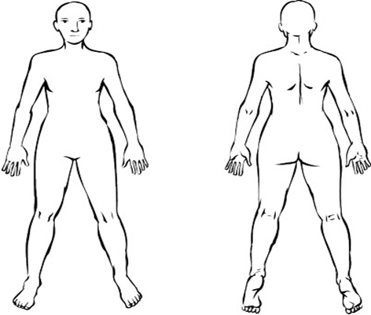**Body map completed by:**

1. Mark on ‘body’ diagram, where rash is visible.
2. If treatment is prescribed, complete box below:

|  |  |  |  |  |
| --- | --- | --- | --- | --- |
| Date & time 1st treatment applied | Name of person applying treatment | Linen changed – please tick | Date & time treatment removed | Name of person completing this action |
|  |  |  |  |  |
| Date & time 2nd treatment applied | Name of person applying treatment | Linen changed – please tick | Date & time treatment removed | Name of person completing this action |
|  |  |  |  |  |