**Infection Prevention and Control Checklist –*Clostridioides Difficile* Infection *(CDI)***

**Section 1 Resident assessment** to be used **daily** with residents who are suspected of or are known to have CDI, whilst the resident is considered infectious. This should be used in association with your CDI guidelines and followed until the resident is symptom free for 48 hours and has passed a formed stool, or a normal stool for them (**A negative stool specimen is not required**).

**Section 2 General IPC standards** to be used by the IPCT on initial assessment

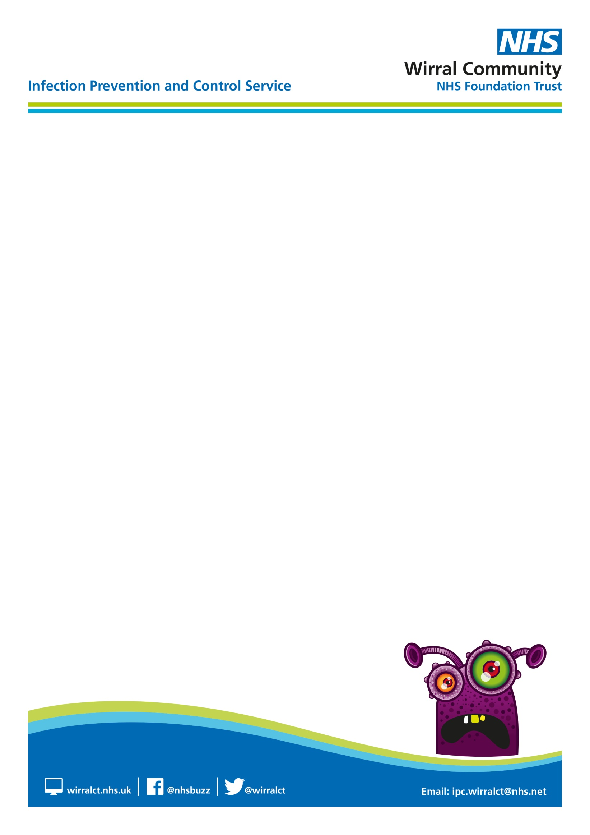

|  |  |  |  |
| --- | --- | --- | --- |
| Resident Name: |  | Date Isolation commenced: |  |
| DOB: |  | Date Isolation Discontinued/Deep Clean Completed: |  |
| Room Number: |  | Signature: |  |
| Date of CDI result: |  | Date: |  |

|  |  |  |  |  |  |  |  |
| --- | --- | --- | --- | --- | --- | --- | --- |
| **Resident Assessment – Section 1** | **Date:** | | | | | | |
|  |  |  |  |  |  |  |
| **(√/x/na)** | | | | | | |
| Is the resident isolated in a single room with en-suite facilities / own commode / designated equipment? |  |  |  |  |  |  |  |
| If a single room is not available, has this been discussed with the infection prevention and control team (IPCT) and action plan completed (see attached)  NB isolation can be stopped when the resident is asymptomatic for 48hrs and has passed a normal stool |  |  |  |  |  |  |  |
| Is appropriate signage displayed? |  |  |  |  |  |  |  |
| If safe to do so is the door to the resident’s room closed?  If unable to close resident’s door has this been identified within the action plan?    not appropriate then an IPCT risk assessment is completed |  |  |  |  |  |  |  |
| Is appropriate PPE available and stored correctly, away from contamination risk, outside the resident’s room? |  |  |  |  |  |  |  |
| Is PPE removed correctly before leaving the residents room and discarded as clinical waste? Hand hygiene must follow removal of PPE |  |  |  |  |  |  |  |
| Is a Bristol Stool Chart (BSC) in use? |  |  |  |  |  |  |  |
| Is the Bristol Stool Chart up to date? |  |  |  |  |  |  |  |
| Is the resident on appropriate C.diff treatment? |  |  |  |  |  |  |  |
| Are staff caring for the resident using soap and water only for hand hygiene |  |  |  |  |  |  |  |
| Are single-use items used (where possible) or equipment dedicated to the resident while in isolation? |  |  |  |  |  |  |  |
| Is the resident’s crockery, cutlery, washed in the dishwasher (thermo disinfection)? |  |  |  |  |  |  |  |
| Are enhanced cleans being performed in the resident’s environment twice daily using a 2-stage cleaning process (detergent/disinfectant) |  |  |  |  |  |  |  |
| Is the resident’s mattress and pillows, clean and in good condition |  |  |  |  |  |  |  |
| If commode is in use, is it clean and in good condition |  |  |  |  |  |  |  |
| Is the resident’s laundry treated as infectious linen and placed in a red alginate bag then into a laundry bag? |  |  |  |  |  |  |  |
| **General IPC standards – Section 2** | | | | | | | |
| **Hand Hygiene (ALCOHOL HAND GEL IS NOT EFFECTIVE AGAINST CDI AND MUST NOT BE USED)** | | | | | | | |
| Are staff witnessed Bare below the elbow? |  |  |  |  |  |  |  |
| Are staff witnessed using the Ayliffe technique for hand hygiene in line with the 5 moments of hand hygiene moments? |  |  |  |  |  |  |  |
| Question a member of staff are they aware of the need to decontaminate hands with soap and water when caring for a patient with unexplained diarrhoea/C.diff |  |  |  |  |  |  |  |
| Are residents offered hand hygiene when required?  (Clinical hand wash basin / wipes where applicable) |  |  |  |  |  |  |  |
| Are regular hand hygiene audits being undertaken? |  |  |  |  |  |  |  |
| **Personal Protective Clothing (PPE)** | | | | | | | |
| Is PPE applied and worn correctly? |  |  |  |  |  |  |  |
| Is PPE readily available throughout the home? |  |  |  |  |  |  |  |
| Is PPE stored correctly away from contamination risk? |  |  |  |  |  |  |  |

|  |  |  |  |  |  |  |  |
| --- | --- | --- | --- | --- | --- | --- | --- |
| **Safe Management of Care Equipment/ Environmental** | | | | | | | |
| Are all resident’s crockery, cutlery, washed in the dishwasher? (thermo disinfectant)? |  |  |  |  |  |  |  |
| Is the general environment visibly clean and clutter free? |  |  |  |  |  |  |  |
| Is the cleaning checklist up to date? |  |  |  |  |  |  |  |
| Are mattress audits up to date? |  |  |  |  |  |  |  |
| Are commodes / raised toilet seats clean and in good condition and included in cleaning schedules? |  |  |  |  |  |  |  |
| **Laundry and Clinical/Healthcare waste** | | | | | | | |
| In the home, is clean linen stored correctly? |  |  |  |  |  |  |  |
| Is all resident waste disposed of as clinical waste? |  |  |  |  |  |  |  |
| Is the sluice room clean and clutter free? |  |  |  |  |  |  |  |
| Does the home have a macerator/ washer disinfector? |  |  |  |  |  |  |  |
| Is the macerator / washer disinfector working well and being used? |  |  |  |  |  |  |  |
| If not, is there a safe system in place to appropriately disinfect receptacles e.g. bed pans / urinals? |  |  |  |  |  |  |  |



**Clostridioides difficile (CDI) action plan for care home**

|  | **Issue Identified** | **Action taken to address issue identified**  ***(To be completed by Nursing Home)*** | **Action completed by** | **Date action completed** |
| --- | --- | --- | --- | --- |
| 1 |  |  |  |  |
| 2 |  |  |  |  |
| 3 |  |  |  |  |
| 4 |  |  |  |  |
| 5 |  |  |  |  |
| 6 |  |  |  |  |
| 7 |  |  |  |  |
| 8 |  |  |  |  |

|  |  |
| --- | --- |
| Resident Name: |  |
| DOB: |  |
| Room Number: |  |



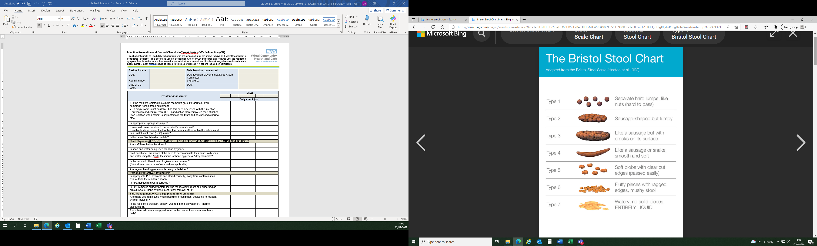

For the purposes of infection control types 5-7 are indicative of diarrhoea. The frequency of passing such stools must also be recorded.

|  |  |  |  |  |
| --- | --- | --- | --- | --- |
| Date | Time | Amount (ml) | Type  (use Bristol Stool Chart) | Comment (specimen sent, presence of blood, mucus etc) |
|  |  |  |  |  |
|  |  |  |  |  |
|  |  |  |  |  |
|  |  |  |  |  |
|  |  |  |  |  |
|  |  |  |  |  |
|  |  |  |  |  |

**GUIDANCE FOR DEEP CLEANING – CARE HOMES**

**What is deep cleaning?**

Deep cleaning is not routine environmental cleaning that is undertaken daily within the care environment, but is additional cleaning that should be undertaken in the following situations:

* following outbreaks and would involve cleaning - the whole environment
* post discharge, transfer or death of individual service user – single room and en suite
* when isolation of a resident with a known infection is no longer required – single room and en suite.

Deep cleaning is the thorough cleaning of all surfaces, floors and soft furnishings and reusable equipment either within the whole environment or in an individual’s room. This will include:

* skirting boards, picture and dado rails
* window sills and frames
* all ledges, shelves and flat surfaces
* chairs, including dining chairs
* pressure relieving cushions and aids
* bed frames
* mattresses
* soft furnishings including curtains and blinds
* curtain rails and tracks
* floors and carpets
* light fittings and lamp shades
* reusable equipment including catheter stands, urinals, bed pans
* wheelchairs, zimmer frames, walking aids
* hoists, including all hoist slings and manual handling aids
* sinks, toilets, baths/showers plus taps, flush and door handles, raised toilet seats, light pull and emergency pull toggles
* commodes
* soap and towel dispensers.

**What equipment is required for deep cleaning?**

Care workers and housekeeping staff that are carrying out deep cleaning should wear disposable plastic aprons and household or disposable gloves. The physical removal of dirt and micro-organisms is achieved by wiping or scrubbing using hot water and neutral detergent. Where a disinfectant is required, an appropriate product this will be advised by the Infection Prevention and Control Service.

**Deep cleaning should be undertaken using**:

* clean bucket
* clean hot water and general purpose detergent
* colour coded disposable cloths
* floor mop with disposable or washable mop head
* vacuum cleaner fitted with a HEPA filter
* steam cleaner or carpet shampooer.

**Deep cleaning procedure:**

* wear personal protective clothing (minimum disposable gloves and apron)
* water and detergent solutions, disposable cloths and mop heads used for cleaning should be changed for each episode of cleaning when moving from one environment to another (room to room) and when the water is visibly dirty or contaminated
* remove/dispose of unwanted items (flowers, equipment etc.)
* take down curtains and send to the laundry
* strip the bed. Clean the mattress with detergent solution and disinfect if necessary
* work from the cleanest to the dirtiest areas, starting at the higher levels and working down.

Clean and disinfect , the following:

* high level surfaces and curtain rails
* fittings and furniture using detergent and water
* door handles and horizontal surfaces
* service user equipment
* bath or shower room
* toilet/commodes
* soft furnishings should be shampooed or steam cleaned
* carpets should be vacuumed (vacuum cleaners should be fitted with a HEPA filter) and then steam cleaned (preferred method)
* discard waste and clean waste bin
* clean all cleaning equipment and leave to dry.

Following deep clean, dispose of gloves and apron and wash hands.



