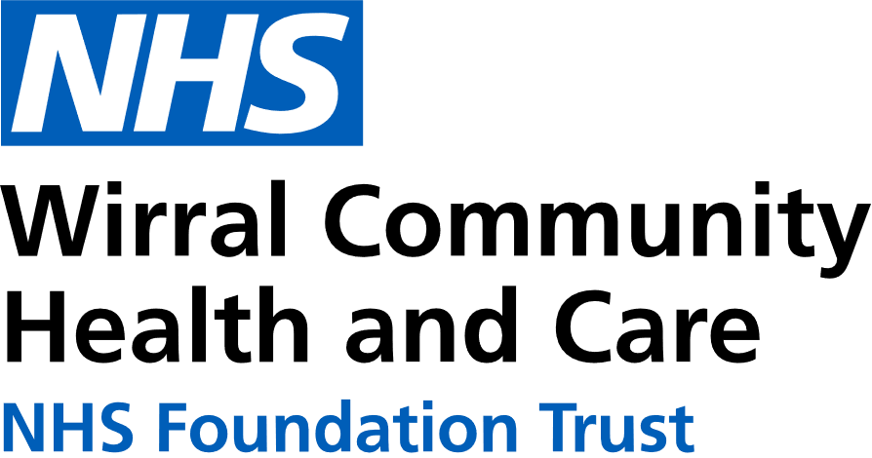
0151 604 7307 (option 1)
wcnt.cardiacrehab@nhs.net
Use the below list to keep track of when you have attended each module.

Educational module | Date attended
Atrial fibrillation (AF) and stroke
Basic Life support and Automated External Defibrillator (AED) use
Cardiac conditions
Cardiovascular disease (CVD) and the heart
Exercise for a healthy heart (core module)
Getting back on track
Healthy eating (core module)
Healthy mind, healthy heart
Heart failure (HF) explained
Managing medicines (core module)
Risk factors (core module)
Stress and your heart health
Steps to success (core module)
Weight management

Cardiovascular Health Education
at Victoria Central
Victoria Central Health Centre, Mill Lane, Wallasey. CH44 5UF (Cardiac Gymnasium, 1st Floor, Wing C)

July – December 2026
We believe your knowledge and understanding of your cardiovascular system and related health conditions are essential in your rehabilitation journey.
Please join us for some educational modules.
Please refer to the module outlines for what is covered in each presentation. For all of our in person educational talks, there is no need to book on, just turn up at the time stated.
We welcome and encourage family, friends, and carers to attend.



All presentations can also be found online with voice-overs on our Trust website and Facebook page by scanning the QR codes below

Trust website Facebook page


In-person education sessions are also delivered at the following venues:
St Catherine’s Health Centre, Derby Road, Birkenhead. CH42 0LQ (Rehab Room 2, Ground Floor, Wing 1)
Marine Lake Health and Wellbeing Centre, Orrysdale Road, West Kirby. CH48 5AA (Health Education Room, Ground Floor)
Please see venue specific timetables for when sessions are being facilitated.
Wednesday 3pm-4pm
Victoria Central
JUL | 1st Managing medicines  8th Steps to Success  15th Risk factors  22nd Stress and your heart health  29th AF and stroke
AUG | 5th Getting back on track  12th Weight management  19th Heart failure explained  26th Cardiac conditions
SEP | 2nd Basic Life support  9th Exercise for a healthy heart  16th Healthy eating  23rd Healthy mind, healthy heart  30th CVD and the heart
OCT | 7th Managing medicines  14th Steps to success  21st Risk factors  28th Stress and your heart health
NOV | 4th AF and stroke  11th Getting back on track  18th Weight management  25th Heart failure explained
DEC | 2nd Cardiac conditions  9th Basic Life support  16th Exercise for a healthy heart  23rd NO TALK  30th NO TALK

