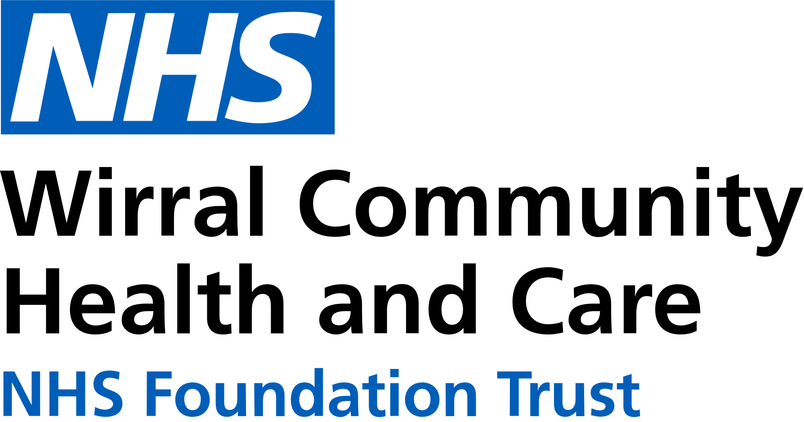
0151 604 7307 (option 1)
wcnt.cardiacrehab@nhs.net
Use the below list to keep track of when you have attended each module.

Educational module | Date attended
Atrial fibrillation (AF) and stroke
Basic Life support and Automated External Defibrillator (AED) use
Cardiac conditions
Cardiovascular disease (CVD) and the heart
Exercise for a healthy heart (core module)
Getting back on track
Healthy eating (core module)
Healthy mind, healthy heart
Heart failure (HF) explained
Managing medicines (core module)
Risk factors (core module)
Stress and your heart health
Steps to success (core module)
Weight management
Cardiovascular Health Education
at Marine Lake
Marine Lake Health and Wellbeing Centre, Orrysdale Road,
West Kirby. CH48 5AA
(Health Education Room, Ground Floor)

January – June 2026
We believe your knowledge and understanding of your cardiovascular system and related health conditions are essential in your rehabilitation journey.
Please join us for some educational modules.
Please refer to the module outlines for what is covered in each presentation. For all of our in person educational talks, there is no need to book on, just turn up at the time stated.
We welcome and encourage family, friends, and carers to attend.



Thursday 3:15pm-4:15pm
Marine Lake
JAN | 1st NO TALK  8th Healthy mind, healthy heart  15th CVD and the heart  22nd Managing medicines  29th Steps to success
FEB | 5th Risk factors  12th Stress and your heart health  19th AF and stroke  26th Getting back on track
MAR | 5th Weight management  12th Heart failure explained  19th Cardiac conditions  26th Basic Life Support and AED use
APR | 2nd Exercise for a healthy heart  9th Healthy Eating  16th Healthy mind, healthy heart  23rd CVD and the heart  30th Managing medicines
MAY | 7th Steps to success  14th Risk factors  21st Stress and your heart health  28th AF and stroke
JUN | 4th Getting back on track  11th Weight management  18th Heart failure explained  25th Cardiac conditions
All presentations can also be found online with voice-overs on our Trust website and Facebook page by scanning the QR codes below

Trust website Facebook page


In-person education sessions are also delivered at the following venues:
St Catherine’s Health Centre, Derby Road, Birkenhead. CH42 0LQ (Rehab Room 2, Ground Floor, Wing 1)
Victoria Central Health Centre, Mill Lane, Wallasey. CH44 5UF (Cardiac Gymnasium, 1st Floor, Wing C)
Please see venue specific timetables for when sessions are being facilitated.

