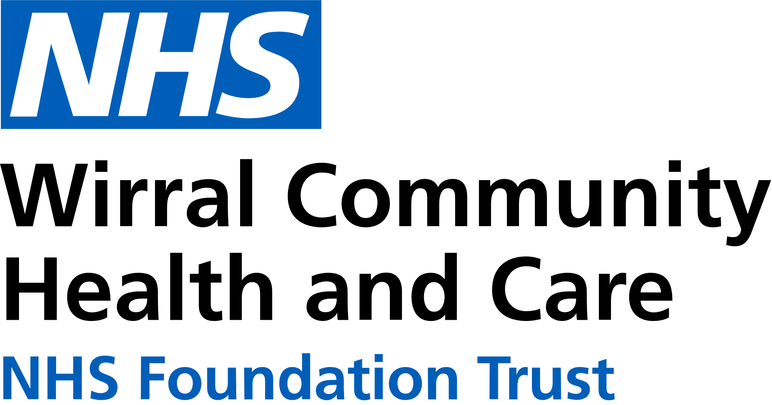
0151 604 7307 (option 1)
wcnt.cardiacrehab@nhs.net
Use the below list to keep track of when you have attended each module.

Educational module | Date attended
Atrial fibrillation (AF) and stroke
Basic Life support and Automated External Defibrillator (AED) use
Cardiac conditions
Cardiovascular disease (CVD) and the heart
Exercise for a healthy heart (core module)
Getting back on track
Healthy eating (core module)
Healthy mind, healthy heart
Heart failure (HF) explained
Managing medicines (core module)
Risk factors (core module)
Stress and your heart health
Steps to success (core module)
Weight management

Cardiovascular Health Education
at Victoria Central
Victoria Central Health Centre, Mill Lane, Wallasey. CH44 5UF (Cardiac Gymnasium, 1st Floor, Wing C)

January – June 2026
We believe your knowledge and understanding of your cardiovascular system and related health conditions are essential in your rehabilitation journey.
Please join us for some educational modules.
Please refer to the module outlines for what is covered in each presentation. For all of our in person educational talks, there is no need to book on, just turn up at the time stated.
We welcome and encourage family, friends, and carers to attend.



All presentations can also be found online with voice-overs on our Trust website and Facebook page by scanning the QR codes below

Trust website Facebook page


In-person education sessions are also delivered at the following venues:
St Catherine’s Health Centre, Derby Road, Birkenhead. CH42 0LQ (Rehab Room 2, Ground Floor, Wing 1)
Marine Lake Health and Wellbeing Centre, Orrysdale Road, West Kirby. CH48 5AA (Health Education Room, Ground Floor)
Please see venue specific timetables for when sessions are being facilitated.
Wednesday 3pm-4pm
Victoria Central
JAN | 7th Risk factors  14th Stress and your heart health  21st AF and stroke  28th Getting Back on Track
FEB | 4th Weight Management  11th Heart Failure Explained  18th Cardiac Conditions  25th Basic Life Support and AED use
MAR | 4th Exercise for a healthy heart  11th Healthy eating  18th Healthy mind, healthy heart  25th CVD and the heart
APR | 1st Managing medicines  8th Steps to Success  15th Risk factors  22nd Stress and your heart health  29th AF and stroke
MAY | 6th Getting Back on Track  13th Weight Management  20th Cardiac Conditions  27th Basic Life Support and AED use
JUN | 3rd Exercise for a healthy heart  10th Healthy eating  17th Healthy mind, healthy heart  24th CVD and the heart

