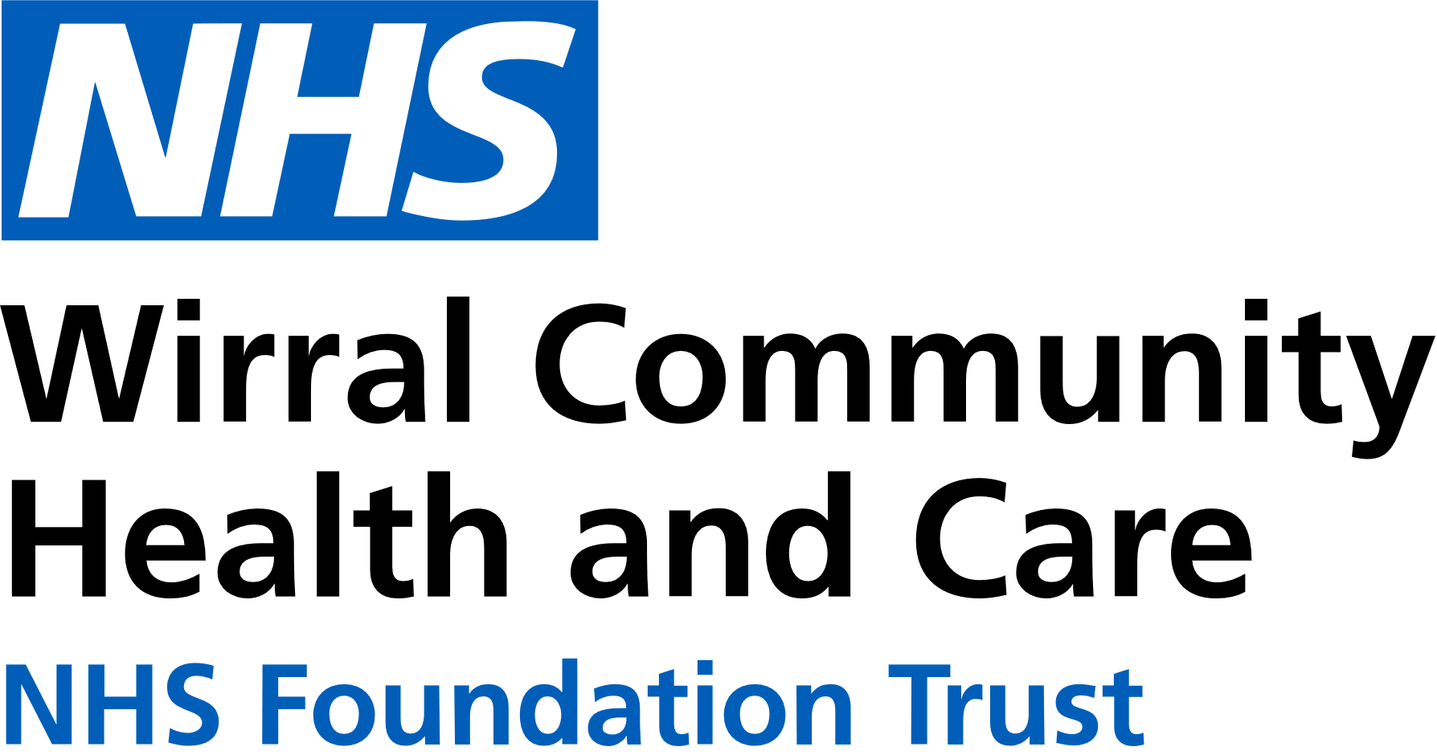
Use the below list to keep track of when you have attended each module.

0151 604 7307 (option 1)
wcnt.cardiacrehab@nhs.net

Educational module | Date attended
Atrial fibrillation (AF) and stroke
Basic Life support and Automated External Defibrillator (AED) use
Cardiac conditions
Cardiovascular disease (CVD) and the heart
Exercise for a healthy heart (core module)
Getting back on track
Healthy eating (core module)
Healthy mind, healthy heart
Heart failure (HF) explained
Managing medicines (core module)
Risk factors (core module)
Stress and your heart health
Steps to success (core module)
Weight management
Cardiovascular Health Education
at St Catherine’s
St Catherine’s Health Centre, Derby Road, Birkenhead. CH42 0LQ (Rehab Room 2, Ground Floor, Wing 1)

January – June 2026
We believe your knowledge and understanding of your cardiovascular system and related health conditions are essential in your rehabilitation journey.
Please join us for some educational modules.
Please refer to the module outlines for what is covered in each presentation. For all of our in person educational talks, there is no need to book on, just turn up at the time stated.
We welcome and encourage family, friends, and carers to attend.





All presentations can also be found online on our Trust website and Facebook with voice-overs

 | Monday 3pm-4pm  St Catherine’s | Tuesday 11am-12am  St Catherine’s | Thursday 3pm-4pm  St Catherine’s | Friday 11am-12pm  St Catherine’s
JAN | 5th Basic Life support and AED use  12th Exercise for a healthy heart  19th Healthy eating  26th Healthy mind, healthy heart | 6th Stress and your heart health  13th AF and stroke  20th Getting back on track  27th Weight management | 1st NO TALK  8th Weight management  15th Heart Failure explained  22nd Cardiac conditions  29th Basic Life support and AED use | 2nd NO TALK  9th Steps to success  16th Risk factors  23rd Stress and your heart health  30th AF and stroke
FEB | 2nd CVD and the heart  9th Managing medicines  16th Steps to success  23rd Risk factors | 3rd Heart Failure explained  10th Cardiac conditions  17th Basic Life support and AED use  24th Exercise for a healthy heart | 5th Exercise for a healthy heart  12th Healthy eating  19th Healthy mind, healthy heart  26th CVD and the heart | 6th Getting back on track  13th Weight management  20th Heart Failure explained  27th Cardiac conditions
MAR  SEPT | 2nd Stress and your heart health  9th AF and stroke  16th Getting back on track  23rd Weight management | 3rd Healthy eating  10th Healthy mind, healthy heart  17th CVD and the heart  24th Managing medicines | 5th Managing medicines  12th Steps to success  19th Risk factors  26th Stress and your heart health | 6th Basic Life support and AED use  13th Exercise for a healthy heart  20th Healthy eating  27th Healthy mind, healthy heart
APR | 6th NO TALK  13th Heart Failure explained  20th Cardiac conditions  27th Basic Life support and AED use | 7th Steps to success  14th Risk factors  21st Stress and your heart health  28th AF and stroke | 2nd AF and stroke  9th Getting back on track  16th Weight management  23rd Heart Failure explained  30th Cardiac conditions | 3rd NO TALK  10th CVD and the heart  17th Managing medicines  24th Steps to success
MAY | 4th NO TALK  11th Exercise for a healthy heart  18th Healthy eating  25th NO TALK | 5th Getting back on track  12th Weight management  19th Heart Failure explained  26th Cardiac conditions | 7th Basic Life support and AED use  14th Exercise for a healthy heart  21st Healthy eating  28th Healthy mind, healthy heart | 1st Risk factors  8th Stress and your heart health  15th AF and stroke  22nd Getting back on track  29th Weight management
JUN | 1st Healthy mind, healthy heart  8th CVD and the heart  15th Managing medicines  22nd Steps to success  29th Risk factors | 2nd Basic Life support and AED use  9th Exercise for a healthy heart  16th Healthy eating  23rd Healthy mind, healthy heart  30th CVD and the heart | 4th CVD and the heart  11th Managing medicines  18th Steps to success  25th Risk factors | 5th Heart Failure explained  12th Cardiac conditions  19th Basic Life support and AED use  26th Exercise for a healthy heart

