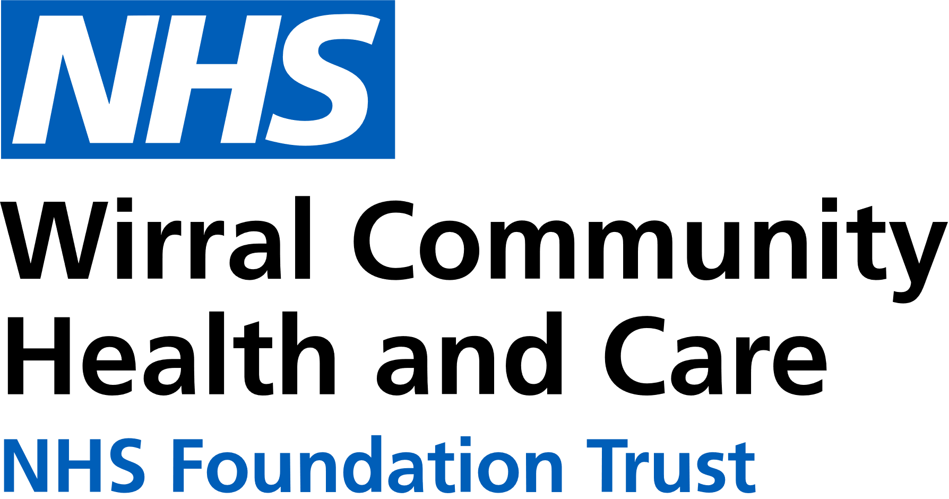
0151 604 7307 (option 1)
wcnt.cardiacrehab@nhs.net
Use the below list to keep track of when you have attended each module.

Educational module | Date attended
Atrial fibrillation (AF) and stroke
Basic Life support and Automated External Defibrillator (AED) use
Cardiac conditions
Cardiovascular disease (CVD) and the heart
Exercise for a healthy heart (core module)
Getting back on track
Healthy eating (core module)
Healthy mind, healthy heart
Heart failure (HF) explained
Managing medicines (core module)
Risk factors (core module)
Stress and your heart health
Steps to success (core module)
Weight management
Cardiovascular Health Education
at Marine Lake
Marine Lake Health and Wellbeing Centre, Orrysdale Road,
West Kirby. CH48 5AA
(Health Education Room, Ground Floor)

July – December 2025
We believe your knowledge and understanding of your cardiovascular system and related health conditions are essential in your rehabilitation journey.
Please join us for some educational modules.
Please refer to the module outlines for what is covered in each presentation. For all of our in person educational talks, there is no need to book on, just turn up at the time stated.
We welcome and encourage family, friends, and carers to attend.



Thursday 3:15pm-4:15pm
Marine Lake
JULY | 3rd Steps to success  10th Risk factors  17th Stress and your heart health  24th AF and stroke  31st Getting back on track
AUG | 7th Weight management  14th Heart failure explained  21st Cardiac conditions  28th Basic Life Support and AED use
SEPT | 4th Exercise for a healthy heart  11th Healthy eating  18th Healthy mind, healthy heart  25th CVD and the heart
OCT | 2nd Managing medicines  9th Steps to success  16th Risk factors  23rd Stress and your heart health  30th AF and stroke
NOV | 6th Getting back on track  13th Weight management  20th Heart failure explained  27th Cardiac conditions
DEC | 4th Basic Life Support and AED use  11th Exercise for a healthy heart  18th Healthy eating  25th BANK HOLIDAY
All presentations can also be found online with voice-overs on our Trust website and Facebook page by scanning the QR codes below

Trust website Facebook page


In-person education sessions are also delivered at the following venues:
St Catherine’s Health Centre, Derby Road, Birkenhead. CH42 0LQ (Rehab Room 2, Ground Floor, Wing 1)
Victoria Central Health Centre, Mill Lane, Wallasey. CH44 5UF (Cardiac Gymnasium, 1st Floor, Wing C)
Please see venue specific timetables for when sessions are being facilitated.

