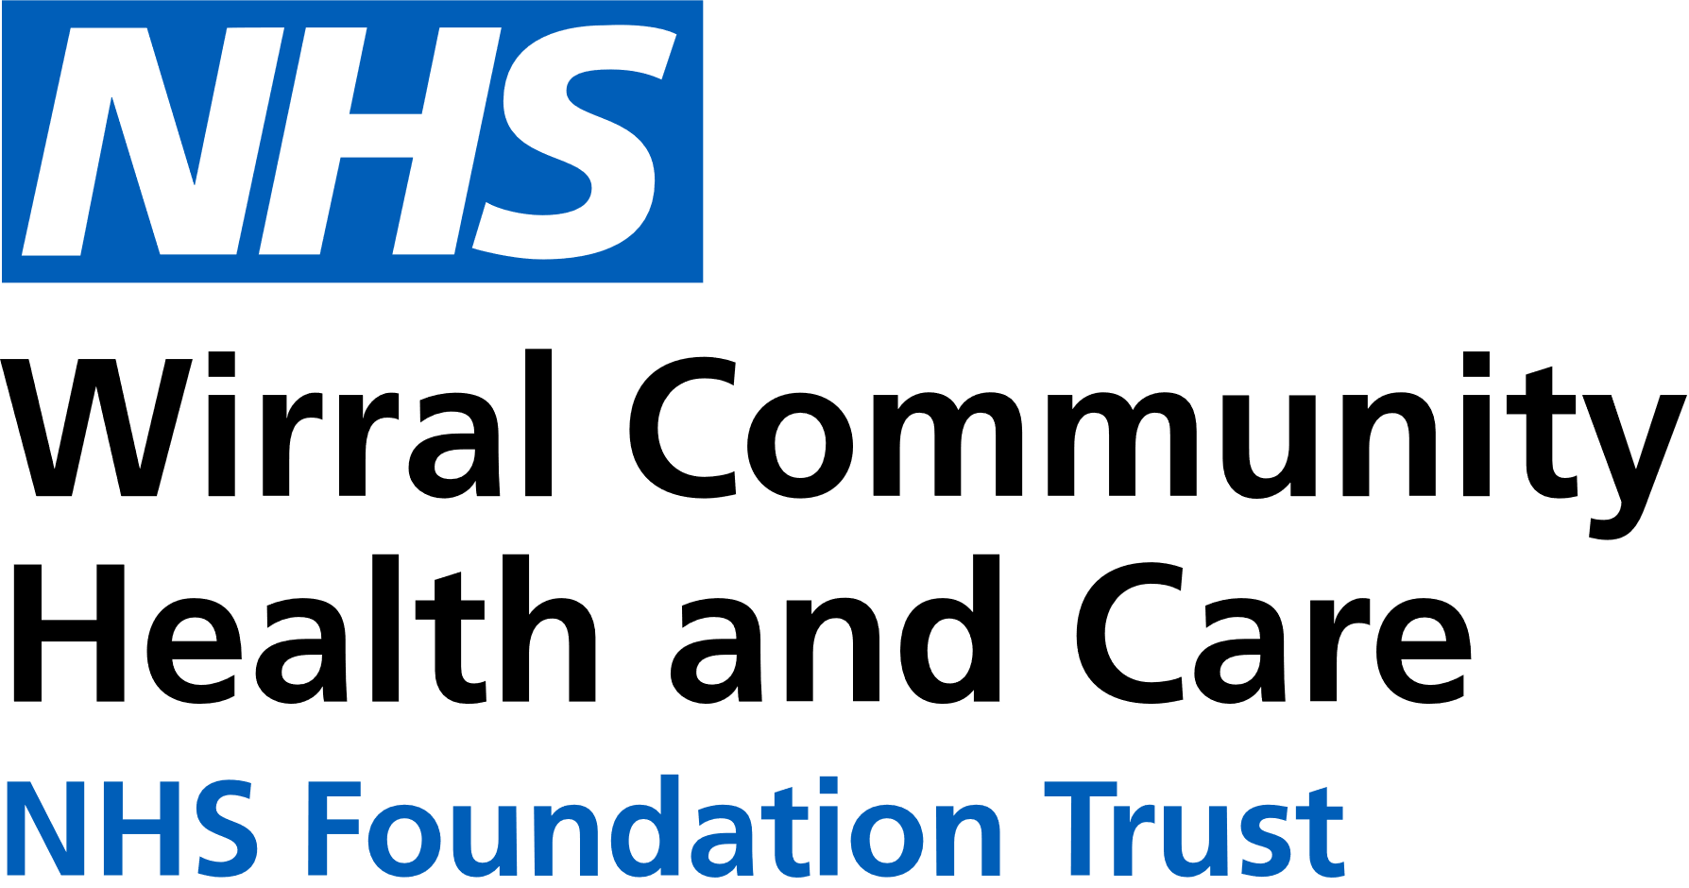
0151 604 7307 (option 1)
wcnt.cardiacrehab@nhs.net
Use the below list to keep track of when you have attended each module.

Educational module | Date attended
Atrial fibrillation (AF) and stroke
Basic Life support and Automated External Defibrillator (AED) use
Cardiac conditions
Cardiovascular disease (CVD) and the heart
Exercise for a healthy heart (core module)
Getting back on track
Healthy eating (core module)
Healthy mind, healthy heart
Heart failure (HF) explained
Managing medicines (core module)
Risk factors (core module)
Stress and your heart health
Steps to success (core module)
Weight management

Cardiovascular Health Education
at Victoria Central
Victoria Central Health Centre, Mill Lane, Wallasey. CH44 5UF (Cardiac Gymnasium, 1st Floor, Wing C)

July – December 2025
We believe your knowledge and understanding of your cardiovascular system and related health conditions are essential in your rehabilitation journey.
Please join us for some educational modules.
Please refer to the module outlines for what is covered in each presentation. For all of our in person educational talks, there is no need to book on, just turn up at the time stated.
We welcome and encourage family, friends, and carers to attend.



All presentations can also be found online with voice-overs on our Trust website and Facebook page by scanning the QR codes below

Trust website Facebook page


In-person education sessions are also delivered at the following venues:
St Catherine’s Health Centre, Derby Road, Birkenhead. CH42 0LQ (Rehab Room 2, Ground Floor, Wing 1)
Marine Lake Health and Wellbeing Centre, Orrysdale Road, West Kirby. CH48 5AA (Health Education Room, Ground Floor)
Please see venue specific timetables for when sessions are being facilitated.
Wednesday 3pm-4pm
Victoria Central
JULY | 2nd Getting back on track  9th Weight management  16th Heart failure explained  23rd Cardiac conditions  30th Basic Life Support and AED use
AUG | 6th Exercise for a healthy heart  13th Healthy eating  20th Healthy mind, healthy heart  27th CVD and the heart
SEPT | 3rd Managing medicines  10th Steps to success  17th Risk factors  24th Stress and your heart health
OCT | 1st AF and stroke  8th Getting back on track  15th Weight management  22nd Heart failure explained  29th Cardiac conditions
NOV | 5th Basic Life Support and AED use  12th Exercise for a healthy heart  19th Healthy eating  26th Healthy mind, healthy heart
DEC | 3rd CVD and the heart  10th Managing medicines  17th Steps to success  24th NO TALK  31st NO TALK

