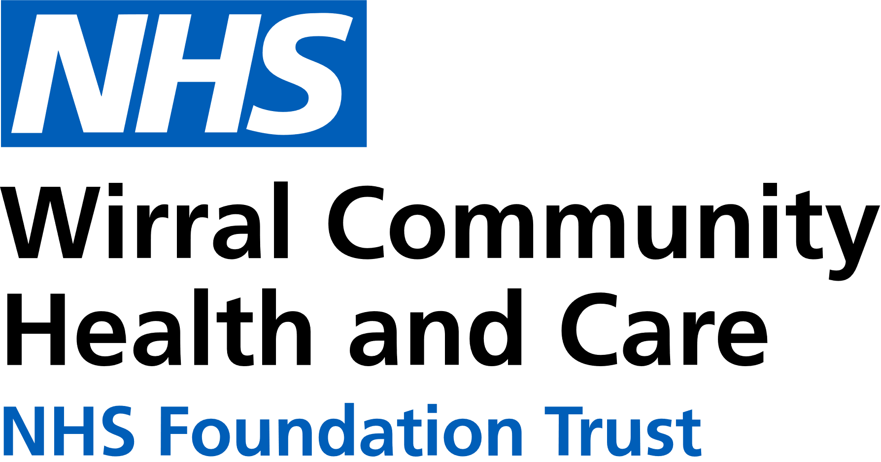
Use the below list to keep track of when you have attended each module.

0151 604 7307 (option 1)
wcnt.cardiacrehab@nhs.net

Educational module | Date attended
Atrial fibrillation (AF) and stroke
Basic Life support and Automated External Defibrillator (AED) use
Cardiac conditions
Cardiovascular disease (CVD) and the heart
Exercise for a healthy heart (core module)
Getting back on track
Healthy eating (core module)
Healthy mind, healthy heart
Heart failure (HF) explained
Managing medicines (core module)
Risk factors (core module)
Stress and your heart health
Steps to success (core module)
Weight management
Cardiovascular Health Education
at St Catherine’s
St Catherine’s Health Centre, Derby Road, Birkenhead. CH42 0LQ (Rehab Room 2, Ground Floor, Wing 1)

July – December 2025
We believe your knowledge and understanding of your cardiovascular system and related health conditions are essential in your rehabilitation journey.
Please join us for some educational modules.
Please refer to the module outlines for what is covered in each presentation. For all of our in person educational talks, there is no need to book on, just turn up at the time stated.
We welcome and encourage family, friends, and carers to attend.





All presentations can also be found online on our Trust website and Facebook with voice-overs

 | Monday 3pm-4pm  St Catherine’s | Tuesday 11am-12am  St Catherine’s | Thursday 3pm-4pm  St Catherine’s | Friday 11am-12pm  St Catherine’s
JULY | 7th Managing medicines  14th Steps to success  21st Risk factors  28th Stress and your heart health | 1st Weight management  8th Heart failure explained  15th Cardiac conditions  22nd Basic Life Support and AED use  29th Exercise for a healthy heart | 3rd Basic Life Support and AED use  10th Exercise for a healthy heart  17th Healthy eating  24th Healthy mind, healthy heart  31st CVD and the heart | 4th AF and stroke  11th Getting back on track  18th Weight management  25th Heart Failure explained
AUG | 4th AF and stroke  11th Getting back on track  18th Weight management  25th BANK HOLIDAY | 5th Healthy eating  12th Healthy mind, healthy heart  19th CVD and the heart  26th Managing medicines | 7th Managing medicines  14th Steps to success  21st Risk factors  28th Stress and your heart health | 1st Cardiac conditions  8th Basic Life Support and AED use  15th Exercise for a healthy heart  22nd Healthy eating  29th Healthy mind, healthy heart
SEPT  SEPT | 1st Heart failure explained  8th Cardiac conditions  15th Basic Life Support and AED use  22nd Exercise for a healthy heart  29th Healthy eating | 2nd Steps to success  9th Risk factors  16th Stress and your heart health  23rd AF and stroke  30th Getting back on track | 4th AF and stroke  11th Getting back on track  18th Weight management  25th Heart failure explained | 5th CVD and the heart  12th Managing medicines  19th Steps to success  26th Risk factors
OCT | 6th Healthy mind, healthy heart  13th CVD and the heart  20th Managing medicines  27th Steps to success | 7th Weight management  14th Heart failure explained  21st Cardiac conditions  28th Basic Life Support and AED use | 2nd Cardiac conditions  9th Basic Life Support and AED use  16th Exercise for a healthy heart  23rd Healthy eating  30th Healthy mind, healthy heart | 3rd Stress and your heart health  10th AF and stroke  17th Getting back on track  24th Weight management  31st Heart failure explained
NOV | 3rd Risk factors  10th Stress and your heart health  17th AF and stroke  24th Getting back on track | 4th Exercise for a healthy heart  11th Healthy eating  28th Healthy mind, healthy heart  25th CVD and the heart | 6th CVD and the heart  13th Managing medicines  20th Steps to success  27th Risk factors | 7th Cardiac conditions  14th Basic Life Support and AED use  21st Exercise for a healthy heart  28th Healthy eating
DEC | 1st Weight management  8th Heart Failure explained  15th Cardiac conditions  22nd NO TALK  29th NO TALK | 2nd Managing medicines  9th Steps to success  16th Risk factors  23rd NO TALK  30th NO TALK | 4th Stress and your heart health  11th AF and stroke  18th Getting back on track  25th BANK HOLIDAY | 5th Healthy mind, healthy heart  12th CVD and the heart  19th Managing medicines  26th BANK HOLIDAY

