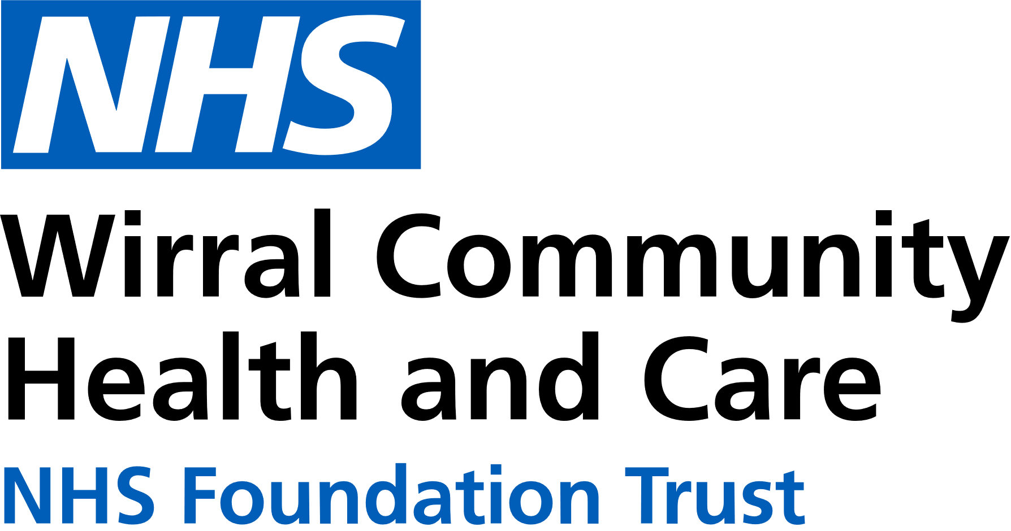

0151 604 7307 (option 1)

[wcnt.cardiacrehab@nhs.net](mailto:wcnt.cardiacrehab@nhs.net)

Use the below list to keep track of when you have attended each module.

|  |  |
| --- | --- |
| **Educational module** | **Date attended** |
| Atrial fibrillation (AF) and stroke |  |
| Basic Life support and Automated External Defibrillator (AED) use |  |
| Cardiac conditions |  |
| Cardiovascular disease (CVD) and the heart |  |
| **Exercise for a healthy heart (core module)** |  |
| Getting back on track |  |
| **Healthy eating (core module)** |  |
| Healthy mind, healthy heart |  |
| Heart failure (HF) explained |  |
| **Managing medicines (core module)** |  |
| **Risk factors (core module)** |  |
| Stress and your heart health |  |
| **Steps to success (core module)** |  |
| Weight management |  |

**Cardiovascular Health Education**

at Marine Lake

Marine Lake Health and Wellbeing Centre, Orrysdale Road,

West Kirby. CH48 5AA

(Health Education Room, Ground Floor)

**January – June 2025**

We believe your knowledge and understanding of your cardiovascular system and related health conditions are essential in your rehabilitation journey.

Please join us for some educational modules.

Please refer to the module outlines for what is covered in each presentation. For all of our in person educational talks, there is no need to book on, just turn up at the time stated.

We welcome and encourage family, friends, and carers to attend.



|  |  |
| --- | --- |
|  | **Thursday 3:15pm-4:15pm**  **Marine Lake** |
| **JAN** | 2nd Stress and your heart health  9th AF and stroke  16th Getting back on track  23rd Weight management  30th Heart failure explained |
| **FEB** | 6th Cardiac conditions  13th Basic Life Support and AED use  20th Exercise for a healthy heart  27th Healthy eating |
| **MAR** | 6th Healthy mind, healthy heart  13th CVD and the heart  20th Managing medicines  27th Steps to success |
| **APR** | 3rd Risk factors  10th Stress and your heart health  17th AF and stroke  24th Getting back on track |
| **MAY** | 1st Weight management  8th Heart failure explained  15th Cardiac conditions  22nd Basic Life Support and AED use  29th Exercise for a healthy heart |
| **JUN** | 5th Healthy eating  12th Healthy mind, healthy heart  19th CVD and the heart  26th Managing medicines |

All presentations can also be found online with voice-overs on our Trust website and Facebook page by scanning the QR codes below

Trust website Facebook page

In-person education sessions are also delivered at the following venues:

**St Catherine’s Health Centre**, Derby Road, Birkenhead. CH42 0LQ (Rehab Room 2, Ground Floor, Wing 1)

**Victoria Central Health Centre,** Mill Lane, Wallasey. CH44 5UF (Cardiac Gymnasium, 1st Floor, Wing C)

Please see venue specific timetables for when sessions are being facilitated.