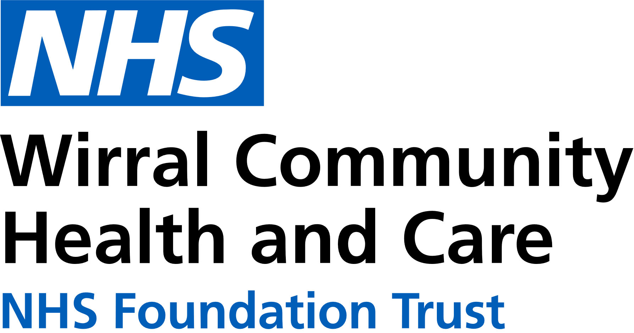

0151 604 7307 (option 1)

[wcnt.cardiacrehab@nhs.net](mailto:wcnt.cardiacrehab@nhs.net)

Use the below list to keep track of when you have attended each module.

|  |  |
| --- | --- |
| **Educational module** | **Date attended** |
| Atrial fibrillation (AF) and stroke |  |
| Basic Life support and Automated External Defibrillator (AED) use |  |
| Cardiac conditions |  |
| Cardiovascular disease (CVD) and the heart |  |
| **Exercise for a healthy heart (core module)** |  |
| Getting back on track |  |
| **Healthy eating (core module)** |  |
| Healthy mind, healthy heart |  |
| Heart failure (HF) explained |  |
| **Managing medicines (core module)** |  |
| **Risk factors (core module)** |  |
| Stress and your heart health |  |
| **Steps to success (core module)** |  |
| Weight management |  |

**Cardiovascular Health Education**

at Victoria Central

Victoria Central Health Centre, Mill Lane, Wallasey. CH44 5UF (Cardiac Gymnasium, 1st Floor, Wing C)

**January - June 2025**

We believe your knowledge and understanding of your cardiovascular system and related health conditions are essential in your rehabilitation journey.

Please join us for some educational modules.

Please refer to the module outlines for what is covered in each presentation. For all of our in person educational talks, there is no need to book on, just turn up at the time stated.

We welcome and encourage family, friends, and carers to attend.



All presentations can also be found online with voice-overs on our Trust website and Facebook page by scanning the QR codes below

Trust website Facebook page

In-person education sessions are also delivered at the following venues:

**St Catherine’s Health Centre**, Derby Road, Birkenhead. CH42 0LQ (Rehab Room 2, Ground Floor, Wing 1)

**Marine Lake Health and Wellbeing Centre**, Orrysdale Road, West Kirby. CH48 5AA (Health Education Room, Ground Floor)

Please see venue specific timetables for when sessions are being facilitated.

|  |  |
| --- | --- |
| **Wednesday 3pm-4pm**  **Victoria Central** | |
| **JAN** | 1st BANK HOLIDAY  8th Cardiac conditions  15th Basic Life Support and AED use  22nd Exercise for a healthy heart  29th Healthy eating |
| **FEB** | 5th Healthy mind, healthy heart  12th CVD and the heart  19th Managing medicines  26th Steps to success |
| **MAR** | 5th Risk factors  12th Stress and your heart health  19th AF and stroke  26th Getting back on track |
| **APR** | 2nd Weight management  9th Heart failure explained  16th Cardiac conditions  23rd Basic Life Support and AED use  30th Exercise for a healthy heart |
| **MAY** | 7th Healthy eating  14th Healthy mind, healthy heart  21st CVD and the heart  28th Managing medicines |
| **JUN** | 4th Steps to success  11th Risk factors  18th Stress and your heart health  25th AF and stroke |