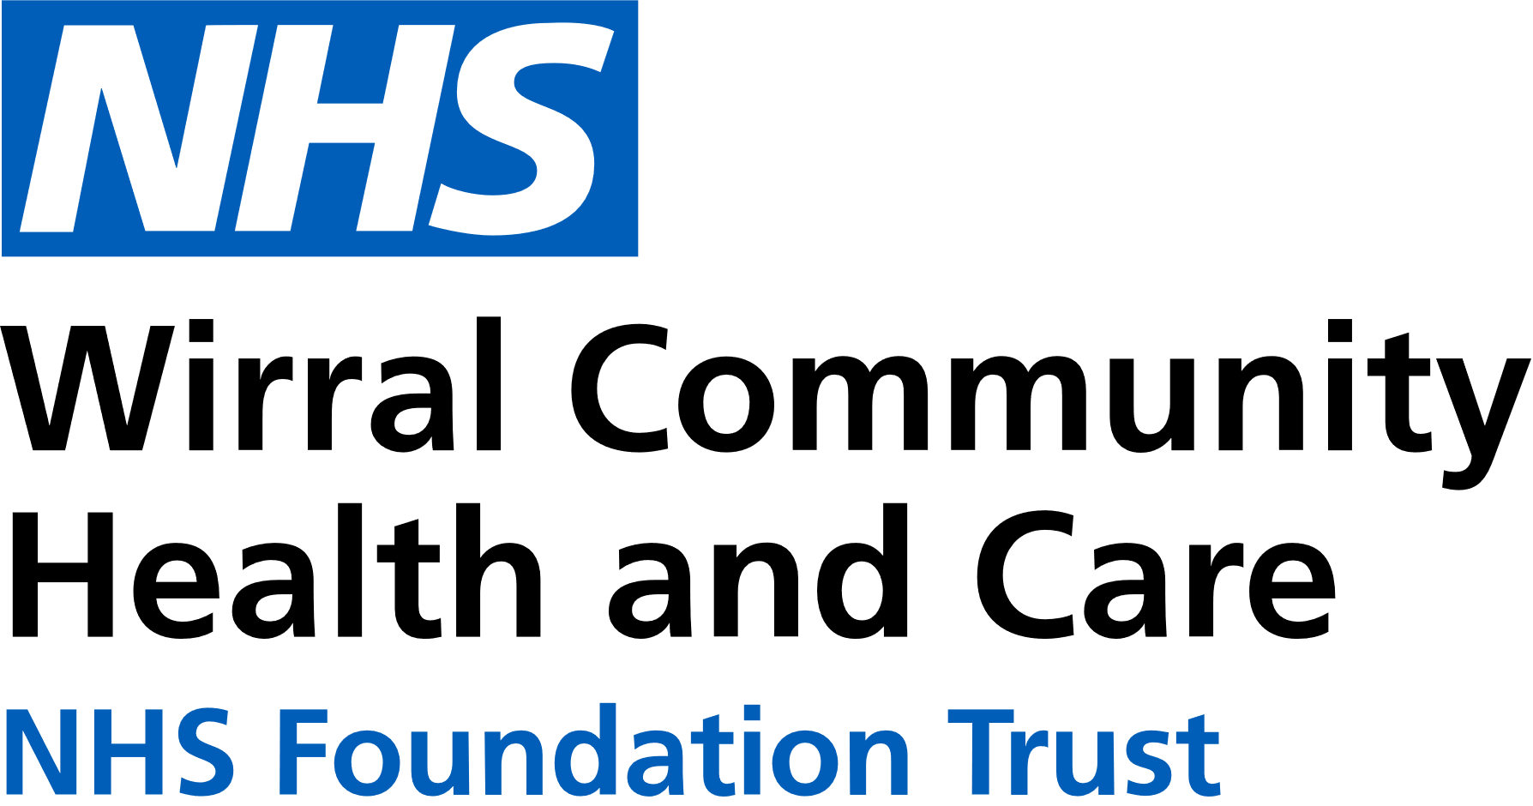

Use the below list to keep track of when you have attended each module.

0151 604 7307 (option 1)

[wcnt.cardiacrehab@nhs.net](mailto:wcnt.cardiacrehab@nhs.net)

|  |  |
| --- | --- |
| **Educational module** | **Date attended** |
| Atrial fibrillation (AF) and stroke |  |
| Basic Life support and Automated External Defibrillator (AED) use |  |
| Cardiac conditions |  |
| Cardiovascular disease (CVD) and the heart |  |
| **Exercise for a healthy heart (core module)** |  |
| Getting back on track |  |
| **Healthy eating (core module)** |  |
| Healthy mind, healthy heart |  |
| Heart failure (HF) explained |  |
| **Managing medicines (core module)** |  |
| **Risk factors (core module)** |  |
| Stress and your heart health |  |
| **Steps to success (core module)** |  |
| Weight management |  |

**Cardiovascular Health Education**

at St Catherine’s

St Catherine’s Health Centre, Derby Road, Birkenhead. CH42 0LQ (Rehab Room 2, Ground Floor, Wing 1)

**January – June 2025**

We believe your knowledge and understanding of your cardiovascular system and related health conditions are essential in your rehabilitation journey.

Please join us for some educational modules.

Please refer to the module outlines for what is covered in each presentation. For all of our in person educational talks, there is no need to book on, just turn up at the time stated.

We welcome and encourage family, friends, and carers to attend.



All presentations can also be found online on our Trust website and Facebook with voice-overs

|  |  |  |  |  |
| --- | --- | --- | --- | --- |
|  | **Monday 3pm-4pm**  **St Catherine’s** | **Tuesday 11am-12am**  **St Catherine’s** | **Thursday 3pm-4pm**  **St Catherine’s** | **Friday 11am-12pm**  **St Catherine’s** |
| **JAN** | 6th Risk Factors  13th Stress and your heart health  20th AF and stroke  27th Getting back on track | 7th Cardiac conditions  14th Basic Life Support and AED use  21st Exercise for a healthy heart  28th Healthy eating | 2nd Healthy eating  9th Healthy mind, healthy heart  16th CVD and the heart  23rd Managing medicines  30th Steps to success | 3rd Weight management  10th Heart failure explained  17th Cardiac conditions  24th Basic Life Support and AED use  31st Exercise for a healthy heart |
| **FEB** | 3rd Weight management  10th Heart failure explained  17th Cardiac conditions  24th Basic Life Support and AED use | 4th Healthy mind, healthy heart  11th CVD and the heart  18th Managing medicines  25th Steps to success | 6th Risk Factors  13th Stress and your heart health  20th AF and stroke  27th Getting back on track | 7th Healthy eating  14th Healthy mind, healthy heart  21st CVD and the heart  28th Managing medicines |
| **MAR**  **SEPT** | 3rd Exercise for a healthy heart  10th Healthy eating  17th Healthy mind, healthy heart  24th CVD and the heart  31st Managing medicines | 4th Risk Factors  11th Stress and your heart health  18th AF and stroke  25th Getting back on track | 6th Weight management  13th Heart failure explained  20th Cardiac conditions  27th Basic Life Support and AED use | 7th Steps to success  14th Risk Factors  21st Stress and your heart health  28th AF and stroke |
| **APR** | 7th Steps to success  14th Risk Factors  21st Stress and your heart health  28th AF and stroke | 1st Weight management  8th Heart failure explained  15th Cardiac conditions  22nd Basic Life Support and AED use  29th Exercise for a healthy heart | 3rd Exercise for a healthy heart  10th Healthy eating  17th Healthy mind, healthy heart  24th CVD and the heart | 4th Getting back on track  11th Weight management  18th Heart failure explained  25th Cardiac conditions |
| **MAY** | 5th Getting back on track  12th Weight management  19th Heart failure explained  26th Cardiac conditions | 1st Healthy eating  8th Healthy mind, healthy heart  15th CVD and the heart  22nd Managing medicines  29th Steps to success | 1st Managing medicines  8th Steps to success  15th Risk Factors  22nd Stress and your heart health  29th AF and stroke | 2nd Basic Life Support and AED use  9th Exercise for a healthy heart  16th Healthy eating  23rd Healthy mind, healthy heart  30th CVD and the heart |
| **JUN** | 2nd Basic Life Support and AED use  9th Exercise for a healthy heart  16th Healthy eating  23rd Healthy mind, healthy heart  30th CVD and the heart | 3rd Risk Factors  10th Stress and your heart health  17th AF and stroke  24th Getting back on track | 5th Getting back on track  12th Weight management  19th Heart failure explained  26th Cardiac conditions | 6th Managing medicines  13th Steps to success  20th Risk Factors  27th Stress and your heart health |