Care Homes

User Guide for Managers

Contents
1. General Navigation and User Preferences 3
1.1. Accessing the Site 3
1.2. Username and Password 3
1.3. Navigation 4
1.4. Changing Password 4
1.5. View Date 5
2. General Functionality 6
2.1. Data Entry Mode 6
2.2. Performance Pop Up 6
2.3. Adding an Action 6
2.4. Adding a Comment 7
2.5. Page Selectors 8
3. Home Page 9
4. Overview 9
5. IPC Environmental Self Audit 10
6. Manager Checklist 11
7. PPE Checklist 12
8. Hand Hygiene 12

General Navigation and User Preferences

Accessing the Site
To access InPhase please enter the following website into any web browser.

https://wirralcarehomes.inphase.com

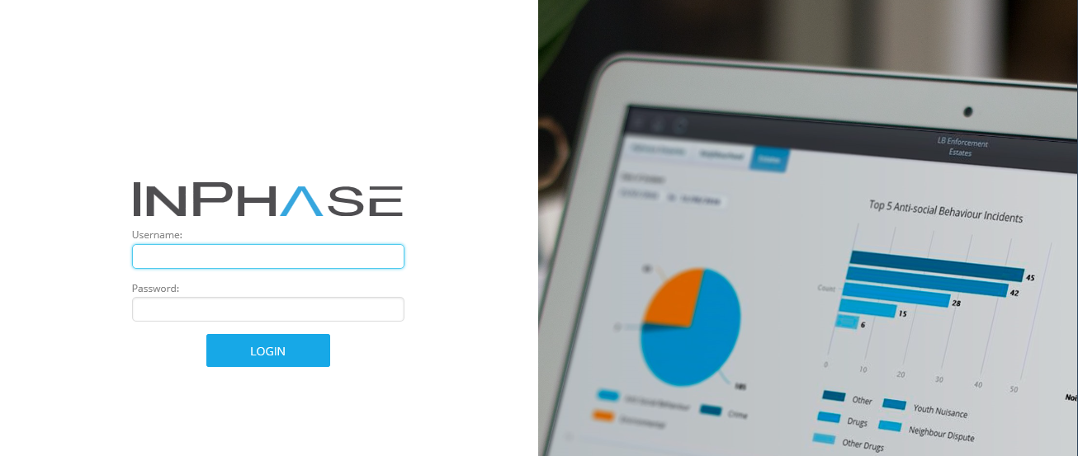

Username and Password

Usernames and passwords can be granted by an administrator.

The username format is; FirstName Surname

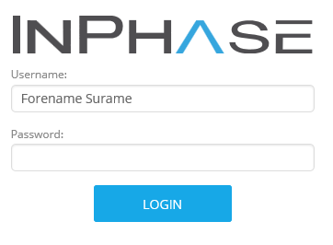

Navigation
To navigate to a page, click on the relevant option on the menu at the top of the page.
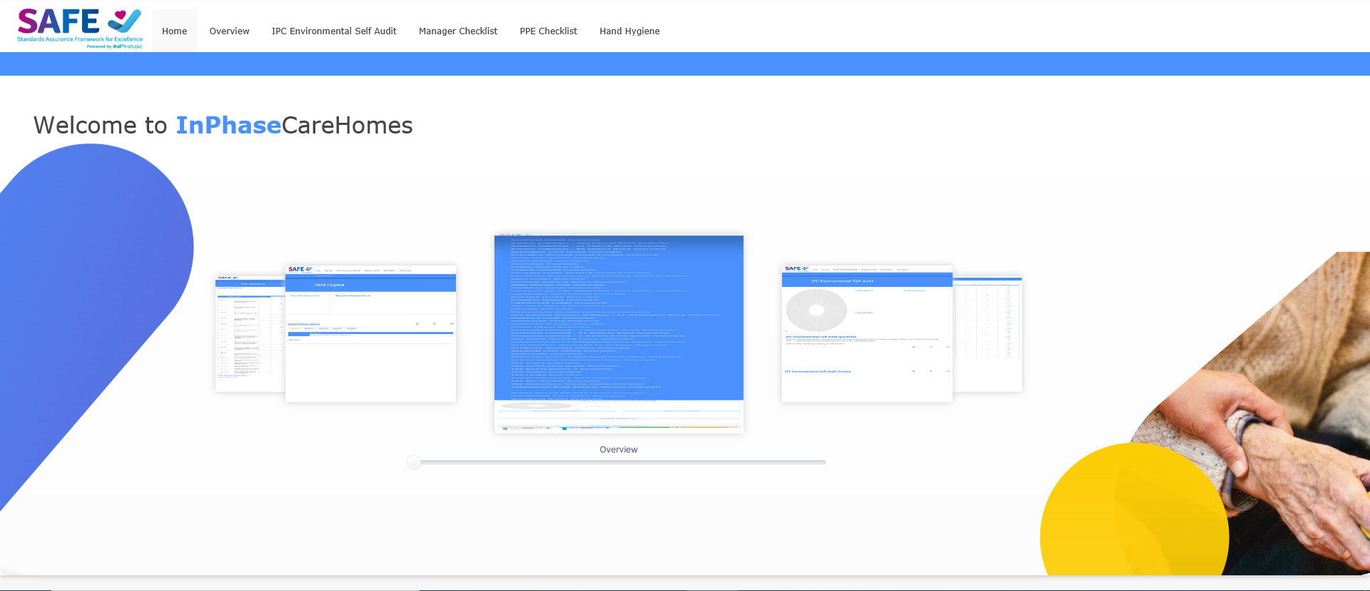

To return to the HOME page, to access your personal dashboard or to refresh the page you are on use the icons in the top left-hand corner of the screen

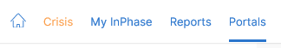

Changing Password
Click on the person icon at the top right-hand corner of the screen. Select Profile from the drop-down menu

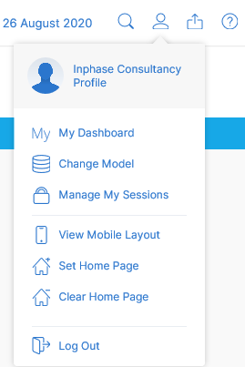

Enter your new password in the fields provided and click save.

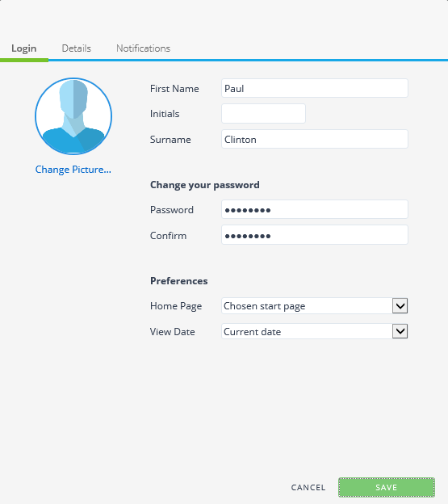

You will notice that you have other preferences that you can change on the profile pop up also.

View Date
Data entered and displayed in InPhase is tracked by date. This means that if you wish to see past date or future time periods you can by simply changing the view date.

The view date is located in the top right-hand corner of the screen. Click the date to produce the calendar.

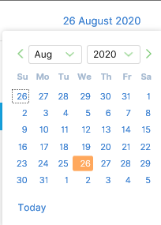

General Functionality
This section documents functions that are used throughout InPhase.

Data Entry Mode
InPhase has a number of tables where data can be entered or changed. The ability to add or change data is dictated by the Data Entry Mode icon. This icon will be positioned to the right-hand side of the table.

Clicking the icon will refresh the table and allow data to be entered or changed.

To exit data entry mode the select the following icon.

Performance Pop Up
If the option to see DETAILS is available either via an icon or by right clicking on an item then a performance pop up is available

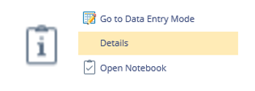

Performance pop ups allow you to either view and edit data (if an action) or view trend information.

Adding an Action
In each module there are areas to add actions. These will be displayed as either page buttons or table icons. Adding an action regardless of the module or page you are on requires the same process.

Clicking on either an Add Action button or Icon will produce the Action pop.

The following fields need to be completed:

- Name
  - Limited to 100 Characters. Should be clear and concise to what the action is.
- Start
  - Calendar Selector. Date of when action will start
- Completion (est)
  - Calendar Selector. Data of when action is estimated (or actually) completed. When first adding a task this should be set as the same as the Due Date
- Due
  - Calendar Selector. Date of when action is due to be completed by
- Owner
  - Defaults to the user adding the action. Can be changed if someone else will be responsible for completing the action

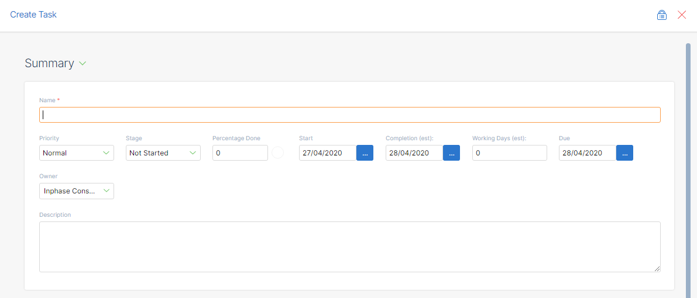

Once you have completed the required fields click Create.

Adding a Comment
Anywhere within InPhase the following icons are seen mean a comment or document can be added.

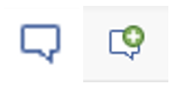

Clicking on either of the above icons will produce a comments pop up box. Type comment in the space provided and click save.

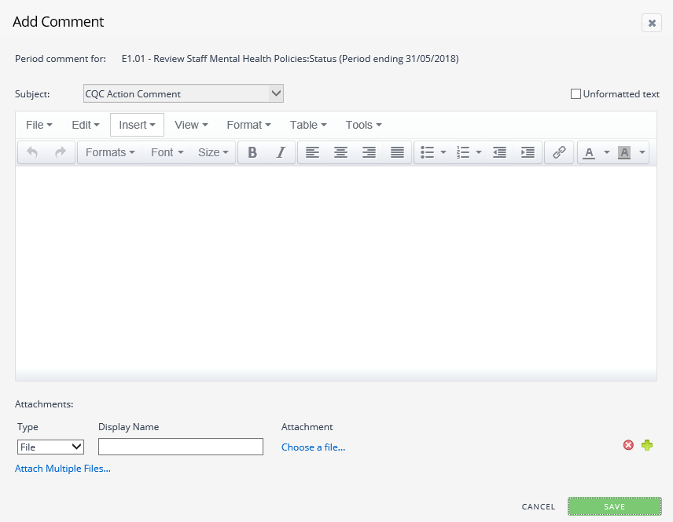

*TIP – You can attached documents or links to a comment using the attachments part at the bottom of the pop up

Page Selectors

On multiple pages you will have the ability to use a drop down list to control the data displayed on the screen. Click on the drop down list to activate it. Either scroll through the available list or start to type into the box provided and the list will auto filter. Once you have made your selection the page will begin to refresh and show data aligned with the selection.

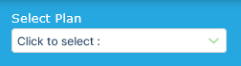

*TIP – Use a asterix as a wildcard function. The system will then search for anything that contains that word

Home Page

Once the user has successfully logged into the system, they should be brought directly to the home page. From here, the user can navigate to any of the other pages on the site by using the menu at the top of the page, or by using the carousel menu on the page itself.

Overview

The overview page provides the user with a high level look into the performance of the other areas in the site. There are graphs and infographics displaying information relating to the following:

- IPC Environmental Self Audit
- Manager Checklist
- PPE Checklist
- Hand Hygiene
- Improvement Actions

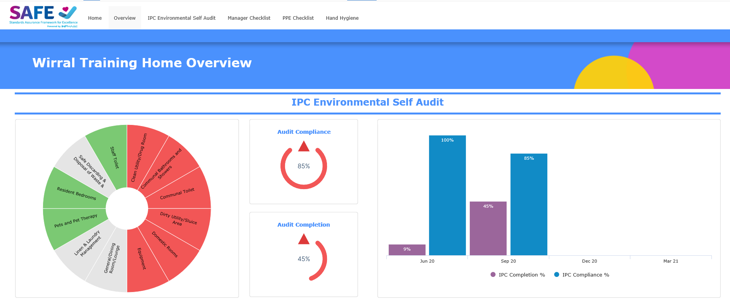
Please note that the series data on the graphs can be toggled on and off by clicking on the chosen series.
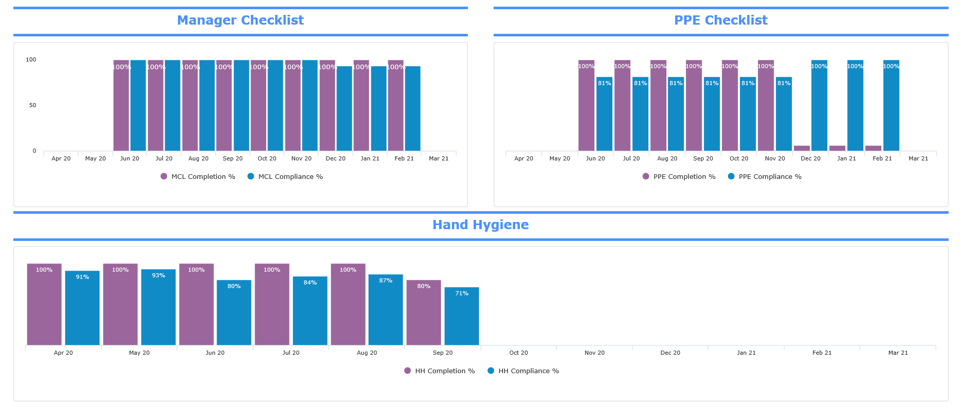
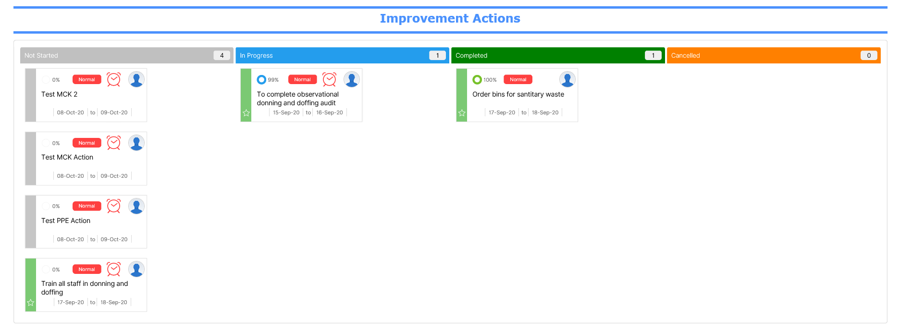

IPC Environmental Self Audit

This page allows the user to see a breakdown of the IPC standards. The sunburst shows the current performance score for the displayed standard, with the Standard Completion table showing the user the progress of completion by each section.

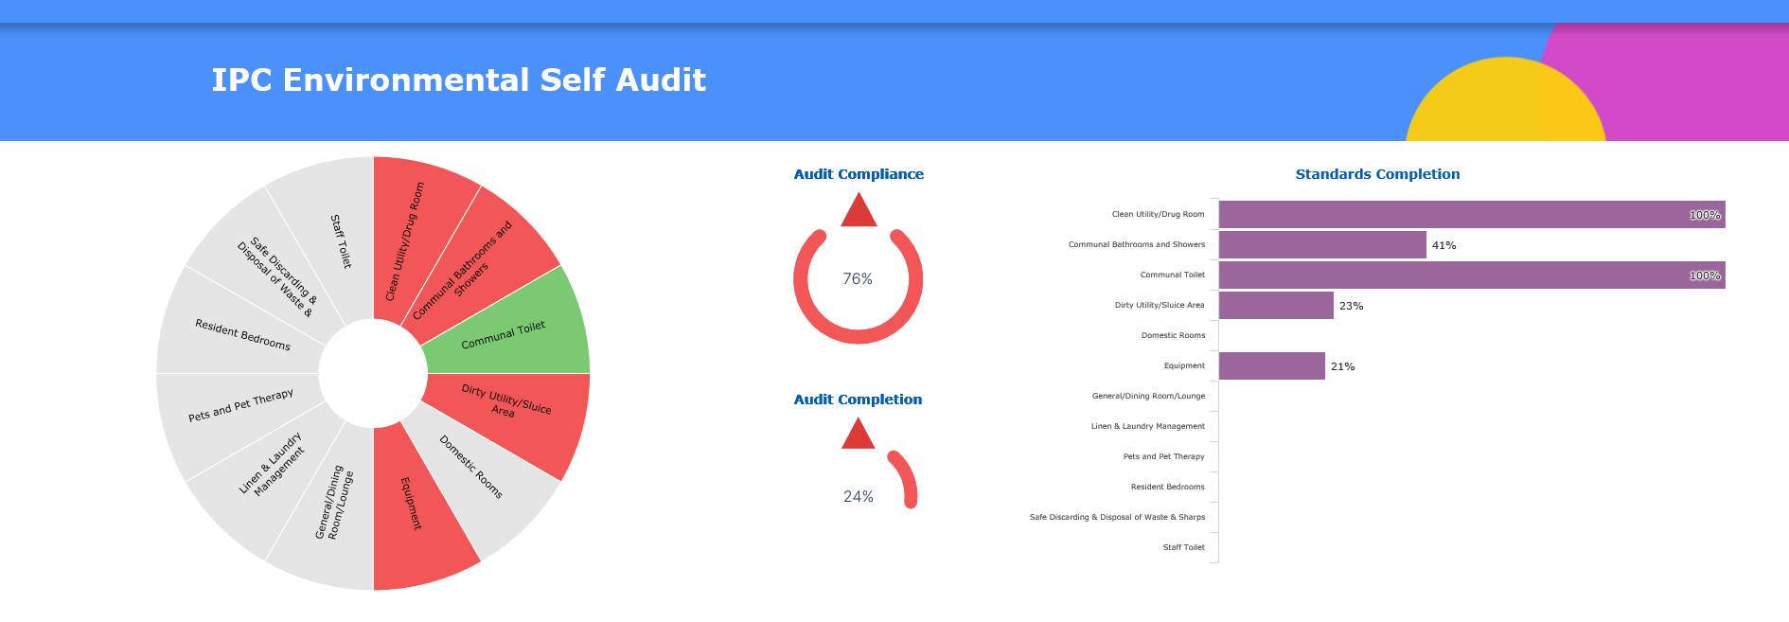

The Sunburst also drives the Self Audit Questions frame. Clicking on a segment of the Sunburst will prompt the Questions frame to update with the relevant questions. By entering data entry mode, the user can then add a rating, commentary, evidence and related actions. Any actions added will be displayed in the table below.

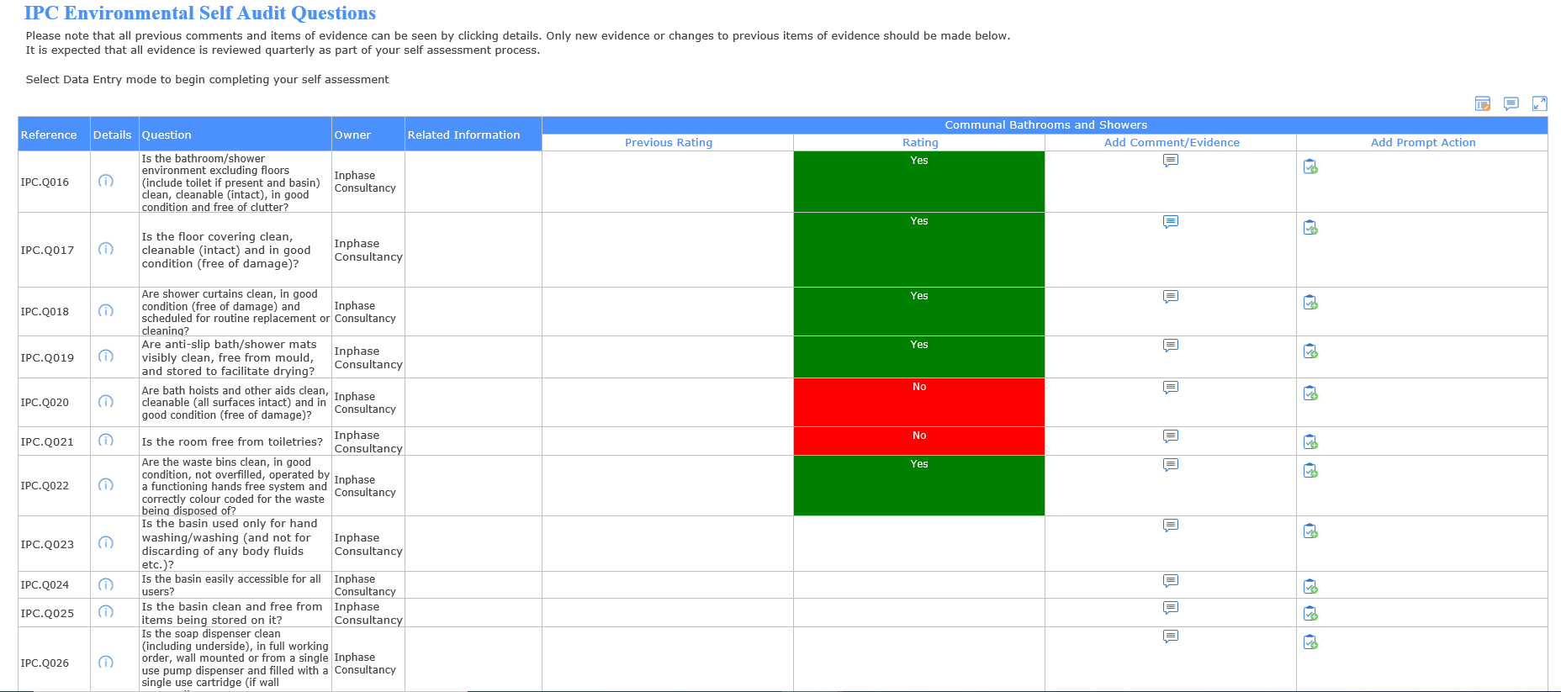

Manager Checklist

This page provides the user with an infographic displaying their Care Home Score, and a table containing the manager checklist questions. The user can enter data entry mode to answer the questions, include additional information and add commentary.

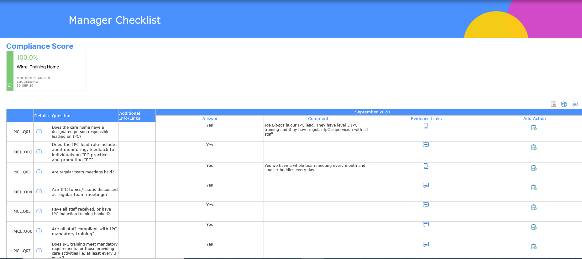
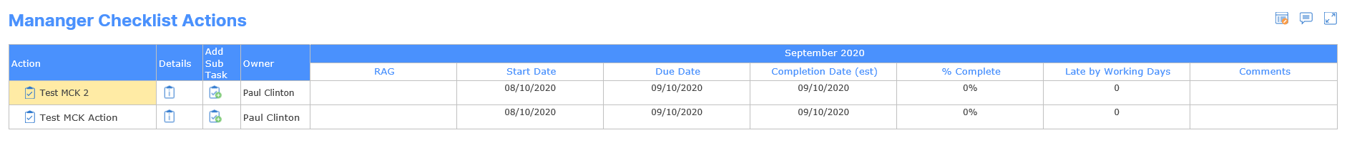

PPE Checklist

This page follows the same structure as the Manager Checklist, with an infographic displaying the Care Home score, and the table beneath detailing the checklist questions. As with the other tables on the site, the user can enter data entry mode to answer and add commentary.

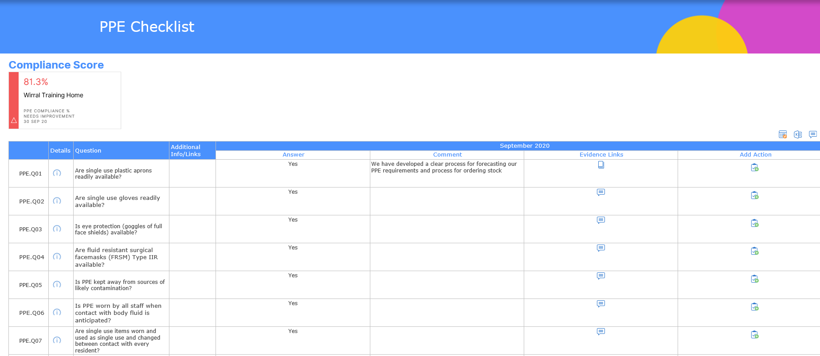
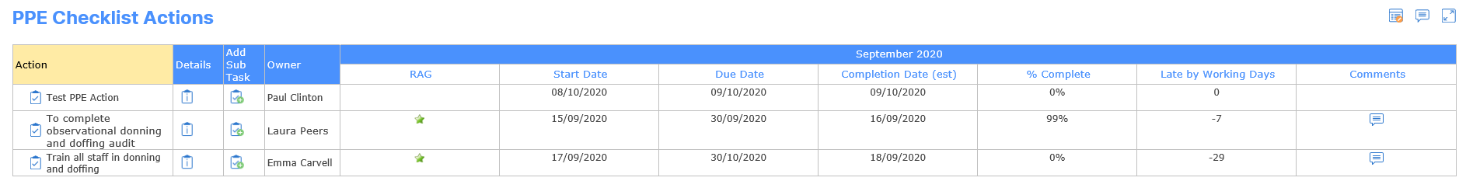

Hand Hygiene

This page allows the user to view the overall compliance score and observational compliance scores. The user can also access data entry mode to add narrative to each observation.

